** Community District Education Council 26**

**New York City Department of Education**

***Address:* 61-15 Oceania Street, Bayside, NY 11364 *Phone:*  (718) 631-6927 *Fax:* (718) 631-1347 *E-mail:* CEC26@schools.nyc.gov.**

**Alan Ong (Borough Appointee) Wendy Pelle-Beer Roy Mendez Leslie Rubenstein Michelle Liu**

*President of the Council First Vice President**Second Vice President**Recording Secretary Treasurer*

*Council Members:* **J Danielle Giunta h Chin**

**Shajid Ali Mohammed Bobby Thind Community Superintendent**

**Dilip Nath David Wong District 26**

**Evelyn Schechter (Borough Appointee)** **Shengchao Yu**

**Olivia Esposito (Student member)** **Website: www.cdec26.org**

**Community Education Council District 26 (CDEC26) Minutes**

**February 25, 2016**

**Location: M.S. 74 61-15 Oceania Street, Queens, NY 1136**

**Calendar Meeting**

**Minutes Approved on March 28, 2016**

1. ***CDEC26 meeting called to order and roll call at 7:08 P.M.***

**Present**: Alan Ong (President), Wendy Pelle-Beer (First Vice-President), Roy Menendez (Second Vice-President), Leslie Rubenstein (Recording Secretary), Shajid Ali Muhammad, Dilip Nath, Bobby Thind, David Wong, Olivia Esposito (Student Member)

**Absent**: Evelyn Schechter (unexcused), Shengchao Yu (unexcused)

**Also Present**: Superintendent District 26 Danielle Giunta, District Family Leadership Coordinator Lori Butera and Dr. Tara Davidson.

1. **School Construction Authority(SCA) Presentation on 2016 Amendment to 2015-2019 Capital Plan by Danielle Schaeffer***(please see addendum 1 of the presentation)*
2. District 26 will fund projects for 924 seats in 2 projects. One of the projects is unsited.
3. The second project is PS 332 scheduled to open in September 2017.
4. Additional need of 1580 seats.
5. CDEC requests for capital plan are due March 18th.
6. **Superintendent’s Report:**
7. **Proposed 2017 Budget Allocation Presentation: Fair Student Funding presented by Brenda Arujo & Superintendent Danielle Giunta** (*please see addendum 2 of the presentation)*
8. NYC is $2 Billion short of the CFE mandated level of funding.
9. Comments may be submitted by April 19, 2016.
10. **Changes to NYS Grades 308 ELA and Math Exams presented by Superintendent Giunta**
11. Greater involvement of educators in test development
12. Decrease in number of test questions
13. 1 less passage on ELA and fewer questions
14. fewer questions on math
15. Shift to untimed testing - students can work as long as they are “productively working”
16. Tests are not the sole indicator of promotion and for this year is not part of teacher evaluation.
17. **Traffic Survey update presented by Dr. Tara Davidson**
18. 100% of schools responded.
19. Double/Triple Parking, speeding and illegal U-turns were the most frequently cited problems.
20. Best practices developed by each school were listed on the survey.
21. Results will be shared with principals at the next Leadership Team Meeting.
22. Discussion of need for more crossing guards ensued. Alan requested more information regarding increased funding that was promised by Mayor’s Office for Vision Zero. Council Member Rozic’s representative said that he would follow up on that and report back to the Superintendent.
23. President of the PTA President’s Council discussed the upcoming Legislative Breakfast and explained the priorities, including traffic safety and crossing guards. He advised CDEC members to forward any other concerns that should be added to the agenda.
24. **Public Comments:**
25. Lori Butera highlighted upcoming program for parents; Ronald McDonald Fun Run at St. John’s on April 16th at 915 a.m.; DOE Spring Break STEM camp by lottery;
26. Mary Vaccaro highlighted the dinner dance on March 31st and announced honorees.

1. *Council Member (CM) Dilip Nath moved to adjourn Calendar Meeting at 8:29. CM Tarvinder Thind seconded the motion.* *All in favor. Meeting adjourns at 8:49 P.M.*

**Community Education Council District 26 (CDEC26) Minutes**

**February 25, 2016**

**Location: M.S. 74 61-15 Oceania Street, Queens, NY 1136**

**Business Meeting**

**Minutes Approved on March 28, 2016**

1. ***CDEC26 meeting called to order and roll call at 8:58 P.M.***

**Present**: Alan Ong (President), Wendy Pelle-Beer (First Vice-President), Roy Menendez (Second Vice-President), Leslie Rubenstein (Recording Secretary), Shajid Ali Muhammad, Dilip Nath, Bobby Thind, David Wong, Olivia Esposito (Student Member)

**Absent**: Evelyn Schechter (unexcused), Shengchao Yu (unexcused)

**Also Present**: Superintendent District 26 Danielle Giunta, District Family Leadership Coordinator Lori Butera and Dr. Tara Davidson.

1. **Approval of January minutes:** Council Member (CM) Dilip Nath motioned to approve the January minutes *CM Tarvinder (Bobby) Thind seconded the motion. Motion passed unanimously. January 28. 2016 minutes are approved.*
2. **Treasurer’s report:** CDEC26 President Alan Ong reviewed the Treasurer’s Report.
3. President Alan Ong discussed the need to allocate $300 to continue the lease on the copier. *CM Dilip Nath made a motion to approve that allocation. CM Leslie Rubenstein seconded the motion. All approved.* ***(please see addendum 3)***
4. Discussion regarding modifications to the budget ensued*. CM Dilip Nath made a motion to accept the modifications as described on the handout reviewed by the CDEC. CM Tarvinder Thind seconded the motion. Motion passed unanimously.* President Ong explained that any money left in the budget would be transferred to a P-card. He asked members to let Farjana Faruk know if they will be attending the UFT Dinner Dance.
5. **Presidents Reports ,Councilmembers Reports & Committee Reports:**
6. President Alan Ong discussed student graduation awards. CDEC will create list of criteria for each award and forward to Danielle for guidance prior to sending it out to principals.
7. CM Roy Menendez reported on the UFT Meet and Greet that he attended.
8. President Alan Ong announced a tentative date of May 26th for the Ballroom Dance event.
9. CM Leslie Rubenstein suggested that the performance take place prior to honors for retirees, etc.
10. Superintendent Danielle Giunta suggested that we also honor the student council presidents this year as well.
11. CM Leslie Rubenstein suggested that new appointees can be honored but that no speeches should be made.
12. Capital Improvement Plan was discussed and priorities for recommendations were discussed.
13. CM Danielle Giunta suggested that Dr. Tara Davidson can set up Google survey for CDEC members to prioritize their suggestions for the Capital Plan.
14. Members will respond by Monday, March 7th.
15. CM Dilip Nath asked Rezoning committee members to watch their e-mails to choose a date for the next conference call with DOE reps.
16. President Alan Ong asked if we would like a CDEC26 Facebook page? Members agreed.
17. Alan suggested the Queens Quiet Skies group be allowed to present in March.
18. *CM Roy Menendez made a motion to adjourn business meeting. CM Tarvinder Thind seconded the motion. All in favor. Business meeting adjourned at 9:57PM.*

**Respectfully Submitted by,**

**Leslie Rubenstein**

***Recording Secretary***

**Absence:**

**From:** Alan [mailto:aong168@gmail.com]   
**Sent:** Thursday, February 25, 2016 8:25 AM  
**To:** ShengChao Yu  
**Cc:** Cec26 D26  
**Subject:** Re: Agenda for CEC26 February 25, 2016 Meeting

Hi ShengChao,

     Good morning.  Unfortunately I cannot make this an excused absence.  It does not fall into anything listed in the bylaw.  Thanks for letting me know.  I will have Farjana save the paperwork for you. Thanks again.   
  
**On Feb 24, 2016, at 10:10 PM, ShengChao Yu <**[**shengchao.yu2005@gmail.com**](mailto:shengchao.yu2005@gmail.com)**> wrote:**

Hi Alan,

I won't be able to attend the February meeting tomorrow due to schedule conflict. Please mark it as an excused absence for me.  Thanks

best regards

Shengchao

**From:** [drelschechter@gmail.com](mailto:drelschechter@gmail.com) [mailto:[drelschechter@gmail.com](mailto:drelschechter@gmail.com)]   
**Sent:** Monday, February 22, 2016 8:08 AM  
**To:** Cec26 D26; Ong Alan  
**Subject:** February Meeting

Hi Alan and Farjana,

I will be unable to attend this week's meeting as I will be out of town. Farjana, I will stop in to pick up the materials you have for me late next week.   
  
Dr. Evelyn L. Schechter, EdD

On Feb 22, 2016, at 7:38 AM, Cec26 D26 <[CEC26@schools.nyc.gov](mailto:CEC26@schools.nyc.gov)> wrote:

**Addendum 1:**

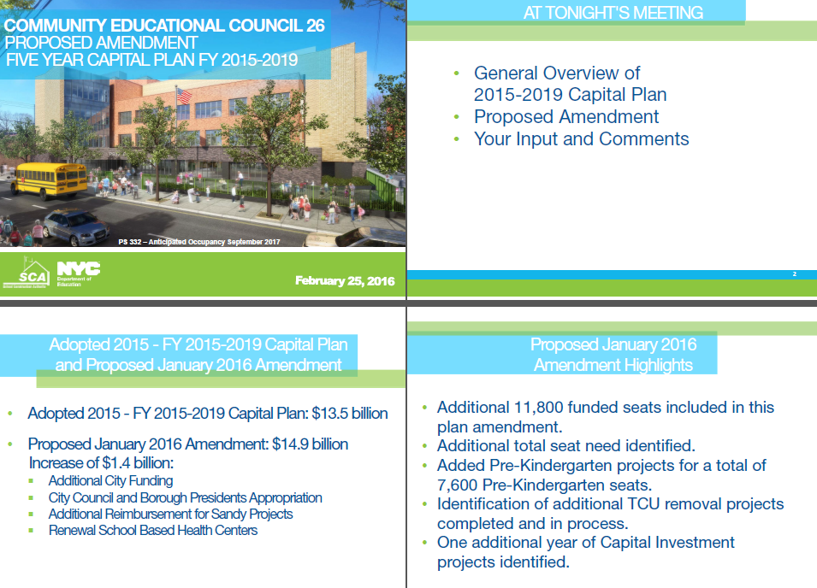

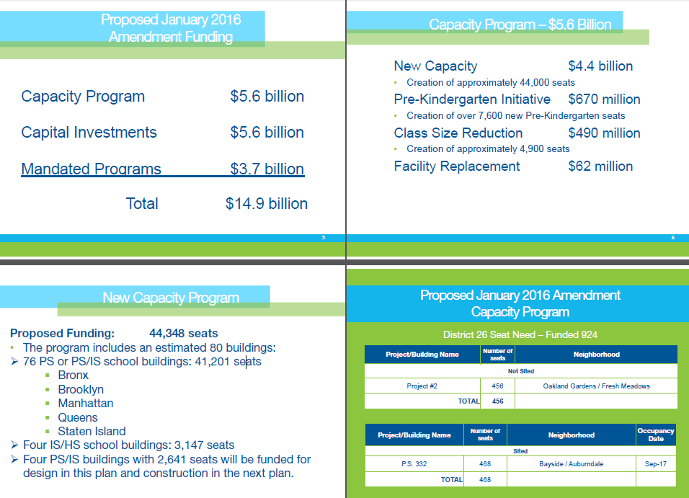

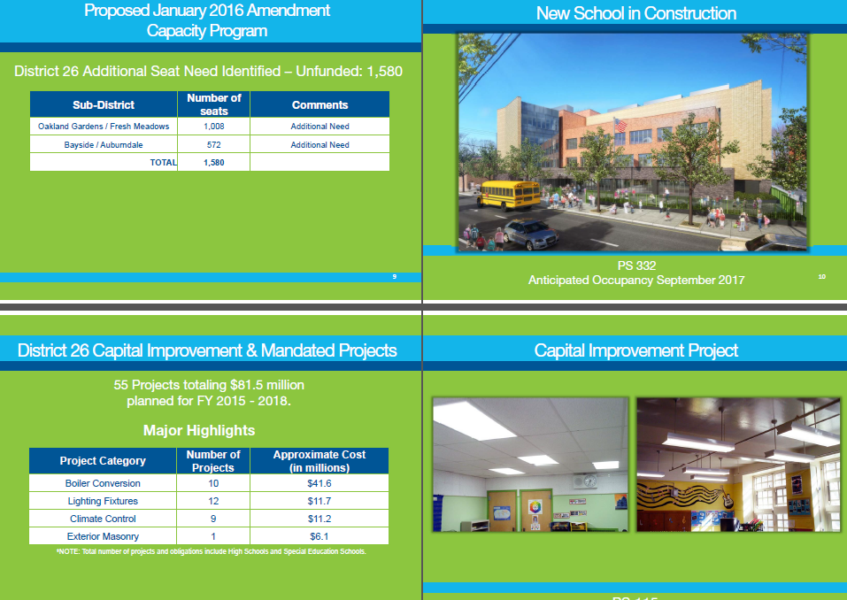

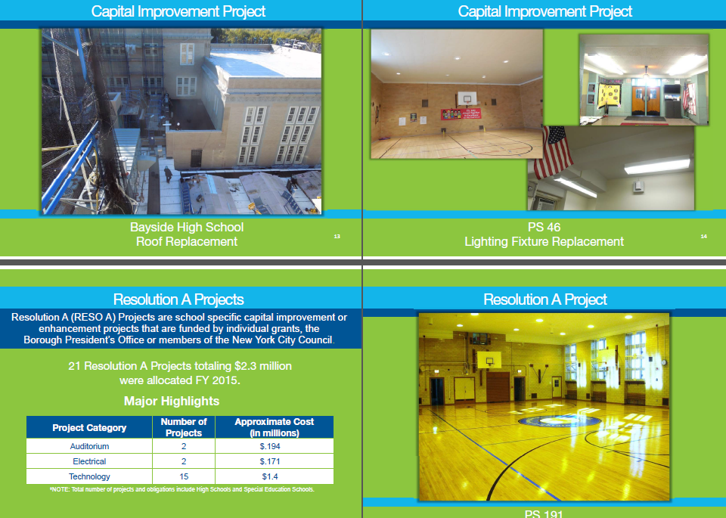

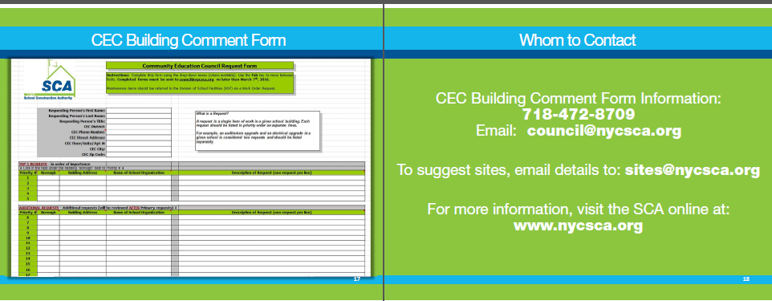

**Addendum 2**

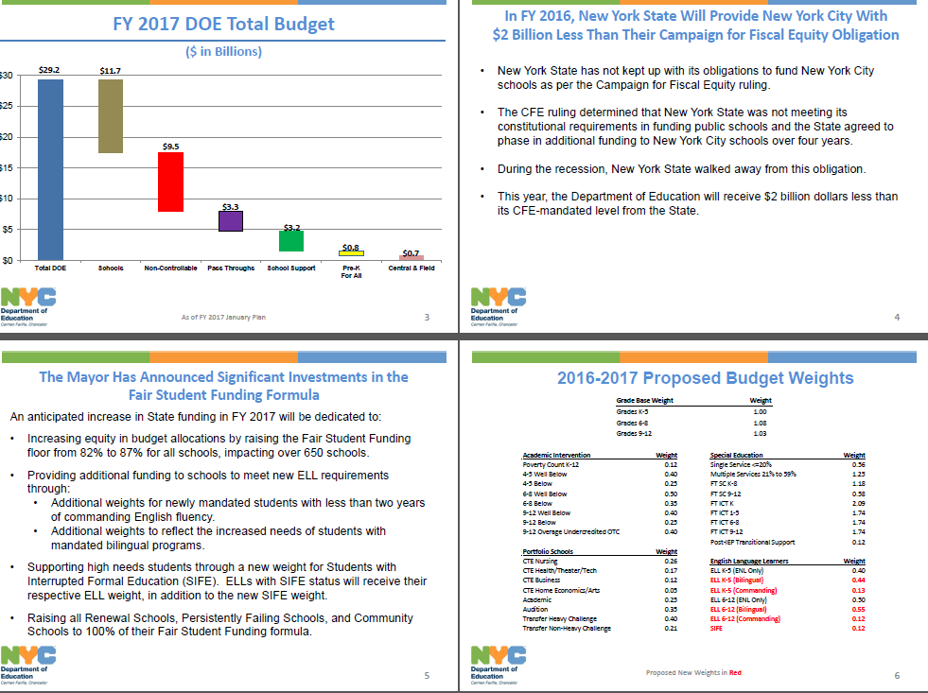

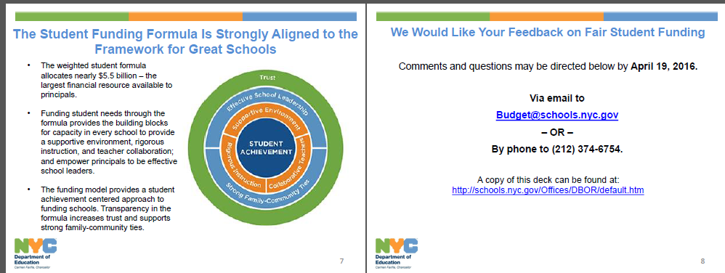

**Addendum 3:**

**Our opening balance is: $16,961.55**

**Our closing balance is: $16,089.09**

**Reimbursements for workshops: $314.27**

**Supplies for Office: $558.19**

**Total Expenditure: $872.46**

Listed Items for January and February

|  |  |  |  |
| --- | --- | --- | --- |
| **Vendor** | **Amount** | **Code** | **Justification** |
| District 26 Workshop | $110.06 | 451 | 1/12/16 Food Capacity Building Workshop |
| District 26 Workshop | $23.96 | 451 | 1/14/16 Food Science Night Workshop |
| District 26 Workshop | $58.55 | 198 | 1/14/16 Supplies Science Night Workshop |
| District 26 Workshop | $73.84 | 198 | 1/14/16 Supplies Science Night Workshop |
| Bagels & Bake | $58.00 | 451 | 1/27/16 Food briefing |
| Bagels & Bake | $122.25 | 451 | 1/27/16 Food CEC January Meeting |
| Staples | $425.80 | 198 | 1/27/16 Office Supplies |

|  |  |  |
| --- | --- | --- |
|  | **Budget** | **Balance** |
| **Copier-**  **Object Code 433** | **$1,872.00** | **$1,872.00** |
| **Member Reimbursement Object Code 496** | **$3,000.00** | **$3,000.00** |
| **P-Card**  **Object Code 179** | **$5,753.00** | **$5,753.00** |
| **Supplies General**  **Object Code 198** | **$2,925.00** | **$1,663.32** |
| **Transportation of Staff**  **Object Code 451** | **$5,000.00** | **$2,600.77** |
| **Professional Service**  **Object Code 686** | **$1,450.00** | **$1,200.00** |
| **Total Expense** | **$3,910.91** |
| **Balance in Budget** | **$16,089.09** |

**Budget Modification**

**From To Amount**

|  |  |  |
| --- | --- | --- |
| Member Reimbursement  (Object Code 496) | Copier  (Object Code 433) | $75.00 |
| Member Reimbursement  (Object Code 496) | Printer | $850.00 |
| Member Reimbursement  (Object Code 496) | P-Card  (Object Code 179) | $1075.00 |
| Supplies General (Object Code 198) | P-Card (Object Code 179) | $800 |
| Professional Services (Object Code 686) | P-Card ( Object Code 179) | $1200 |

**Modified Balance:**

**Member Reimbursement** (Object Code 0496): **$1000**

**Copier** (Object Code 433)**:** **$1947**

**Supplies General** (Object Code 198): **$863.32**

**Transportation of Staff** (Object Code 451)**:** **$2600.77**

**P-Card** (Object Code 179): **$8,828**