** Community District Education Council 26**

**New York City Department of Education**

***Address:* 61-15 Oceania Street, Bayside, NY 11364 *Phone:*  (718) 631-6927 *Fax:* (718) 631-1347 *E-mail:* CEC26@schools.nyc.gov.**

**Alan Ong (Borough Appointee) Wendy Pelle-Beer Roy Mendez Leslie Rubenstein Michelle Liu**

*President of the Council First Vice President**Second Vice President**Recording Secretary Treasurer*

*Council Members:* **J Danielle Giunta h Chin**

**Shajid Ali Mohammed Bobby Thind Community Superintendent**

**Dilip Nath David Wong District 26**

**Evelyn Schechter (Borough Appointee)** **Shengchao Yu**

**Olivia Esposito (Student member)** **Website: www.cdec26.org**

**Community Education Council District 26 (CDEC26) Minutes**

**March 28, 2016**

**Location: M.S. 74 61-15 Oceania Street, Queens, NY 1136**

**Calendar Meeting**

**Minutes Approved on April 20, 2016**

1. ***CDEC26 meeting called to order and roll call at 7:11 P.M.***

**Present**: Alan Ong (President), Wendy Pelle-Beer (First Vice-President), Dilip Nath, Evelyn Schechter, Bobby Thind, David Wong, Shengchao Yu, Olivia Esposito (Student Member)

**Absent**: Roy Menendez (excused), Leslie Rubenstein (excused), Shajid Ali Muhammad (excused)

**Also Present**: Superintendent District 26 Danielle Giunta, District Family Leadership Coordinator Lori Butera and Dr. Tara Davidson.

1. **School Safety :***(SSA Brian David & Commanding Officer Suzanne Catoggio of Queens North)*
2. C.O. Catoggio presented information regarding safety procedures in schools. In order for children to be safe, it is important that kids are safe outside of schools and in the community. Currently, Queens North is outreaching and overseeing kids outside of schools as well. She introduced NYPD community outreach manager SSA Brian Davis to CDEC26.
3. **Queens Quiet Skies-**  *Janey Mcceaney*
4. Queens Quiet Skies was formed 3.5 years ago because of noise pollution and aviation issues.
5. District 26 is impacted by LaGuardia Airport Runway 13 which points directly to District 26. Most flights take off from runway 13 from LaGuardia.
6. Next-gen (new satellite based airplane control) will increase planes takeoff from 20 second to 2 second. FAA identified 125 next-gen programs in NYC. Next-gen does not have to follow environmental routes.
7. Congresswomen Grace Meng introduced a bill that will switch regulations from FAA to environmental protection and Department of Health. The reason for that is FAA focuses on safety and not environmental or health.
8. If you are impacted by noise pollution from airplane, you can have your house insulated through a program.
9. **Superintendent’s Report:**
10. **ELL Service Part 154**  (*please see addendum1 for the presentation)*
11. ESL is replaced with ENL (English as new language).
12. Slide 3 explains the breakdown of the subgroups in ENL’s. There are 5 types of ENL students.
13. Entering
14. Emerging
15. Transitioning
16. Expanding
17. Commanding
18. Slide 5 presents ENL students in District 26(D26) schools. Every school in D26 has ENL students. District 26 met their Annual Measureable Annual Objective (AMAO) which means that D26 exceeded NYS expectation. We continuously exceed targets in D26.
19. Slide 8 & 9 explains ENL students meeting Math and ELA proficiency. It takes 4-7 years for ENL students to fully grasp testing and language. Given the appropriate time, ENL students outperform general students.
20. **Dual Language Programs:**
21. District 26 can work together with SLT, School and Community to create Dual Language Programs. There are funds ($10,000-$25,000) that are available for schools for Dual Language Programs.
22. To start a Dual Language Program, take a survey for the program (20-25 parents). Parent can create committee and needs to find a dual certified teacher; 2 are ideal.
23. **Superintendent Giunta:**
24. 2016-2017 School Calendar is on the website for parents to review for next year.
25. District 26 had a very successful legislative breakfast on March 11, 2016.
26. Superintendent spoke about importance of taking ELA and Math exams in April. It provides data and feedbacks to increase performance in future.
27. Superintendent spoke about 2 schools that are exceeding expectation in parent out reach. P.S. 188 have parent needs of assistance program. Parents can contact the parent-coordinator in need of assistance. Then, the parent-coordinator sends out an email to parents to see if anyone can help. P.S. 98 have an outreach program for new family coming into the school district. The children and family works together to communicate in advance and welcomes them to the community. The essence of the program is that the student already has friends before entering the school.
28. **Parent Engagement:**  *Kim D’Angelo*
29. We are finishing How to Develop Your Voice Workshop.
30. Green Survey is due.
31. College Fair is coming up at the Javitz Center.
32. Volunteers are needed for Green Day.
33. From July 7th – August 4th, there will be a summer program at MS 74.

1. **Public Comments:**

1. *Council Member (CM) Dilip Nath moved to adjourn Calendar Meeting at 8:29. CM Evelyn Schechter seconded the motion.* *All in favor. Meeting adjourns at 8:59 P.M.*

**Community Education Council District 26 (CDEC26) Minutes**

**March 28, 2016**

**Location: M.S. 74 61-15 Oceania Street, Queens, NY 1136**

**Business Meeting**

**Minutes Approved on March 28, 2016**

1. ***CDEC26 meeting called to order and roll call at 9:01 P.M.***

**Present**: Alan Ong (President), Wendy Pelle-Beer (First Vice-President), Dilip Nath, Evelyn Schechter ,Bobby Thind, David Wong, Shengchao Yu, Olivia Esposito (Student Member)

**Absent**: Roy Menendez (excused), Leslie Rubenstein (excused), Shajid Ali Muhammad (excused)

**Also Present**: Superintendent District 26 Danielle Giunta, District Family Leadership Coordinator Lori Butera and Dr. Tara Davidson.

1. **Approval of February minutes:** Council Member (CM) Dilip Nath motioned to approve the February 25, 2016 minutes *CM Tarvinder (Bobby) Thind seconded the motion. Motion passed unanimously. February 25, 2016 minutes are approved.*
2. **Treasurer’s report:** CDEC26 Treasurer Michelle Liu reviewed the Treasurer’s Report. *Please see addendum 2.*
3. **Presidents Reports :**
4. CDEC26 submitted their annual Capital Plan request to School Construction Authority.
5. Some of the members attended the Legislative Breakfast and discussed crossing guard and traffic issues.
6. We will send out a letter to City Council Member Grodenchik regarding funding crossing guard for MS 172.
7. President Ong reminded community about Participatory Budgeting in District 26. Parents and students (14 years old and up) can vote in Participatory Budgeting. He shared information about the location to vote.
8. President Alan Ong discussed student graduation awards. Wendy Pelle-Beer and Dr. Evelyn Schechter suggested Most Improved Student Award or Most Perseverance Award.
9. **Councilmembers Reports:**
10. **Committee Reports:**
11. **Rezoning Committee:**
12. Rezoning Committee Chairperson explained the process of rezoning and shared information packets to CDEC26 members for review.
13. Rezoning Committee request for meeting date to change to April 20, 2016 as April 21, 2016 is the day before Jewish holiday.
14. **CDEC26 Business:**
15. *CDEC26 Council Member (CM) Shengchao Yu motioned to approve CDEC 26 meeting date to change to April 20, 2016 and May 31, 2016 Meeting. CM Tarvinder (Bobby) Thind seconded the motion. Motion approved unanimously.*
16. *CDEC26 Council Member (CM) Shengchao Yu motioned to approve proposed rezoning lines. CM Tarvinder (Bobby) Thind seconded the motion. Motion approved unanimously.*
17. Ballroom Dancing:
18. May 31, 2016 will be CDEC26 Annual Ballroom Dancing.
19. We are honoring retiree, student leaders, aspiring leaders, new assistant principals and new principals in District 26.
20. *CM Dilip Nath made a motion to adjourn business meeting. CM Tarvinder Thind seconded the motion. All in favor. Business meeting adjourned at 9:35PM.*

**Respectfully Submitted by,**

**Farjana Faruk**

**Absences:**

**Shajid Ali**

On Mon, Mar 28, 2016 at 1:15 PM, M S Ali <[shajidali@gmail.com](mailto:shajidali@gmail.com)> wrote:

Oh ok. I didn't realize this. For me most cases like today is because of unavoidable work‎.  Next time onwards I will. Site the reason of in advance itself when sending you absence request.   :)

**Roy Mendez**

On Sat, Mar 19, 2016 at 8:58 AM, <[civicschool@aol.com](mailto:civicschool@aol.com)> wrote:

Good morning Alan,

 I will be on military leave during the March meeting.

Roy

**Leslie Rubenstein:**

On Fri, Feb 26, 2016 at 1:01 PM, <[lrubies@verizon.net](mailto:lrubies@verizon.net)> wrote:

Hi Alan,

I just realized that I will be out of town on the date of our next meeting, March 28th.  Can you please ask Farjana to take care of the minutes for that one?

Sorry, I should have let you know last night but I didn't remember that the next meeting was on a Monday.

Take care,

Leslie

**Addendum 1:**

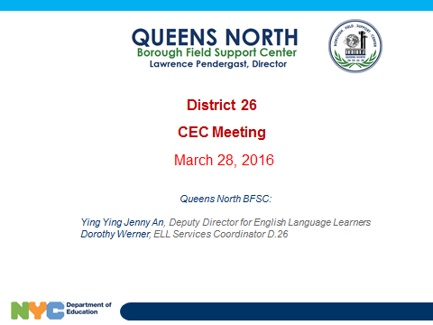 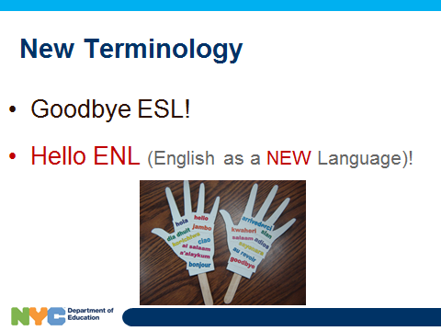

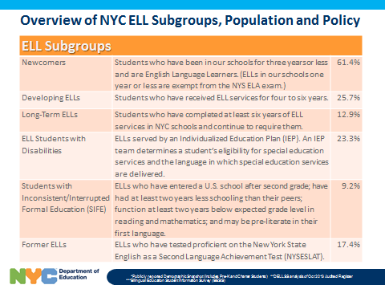 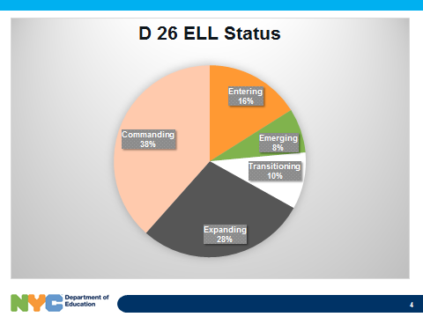

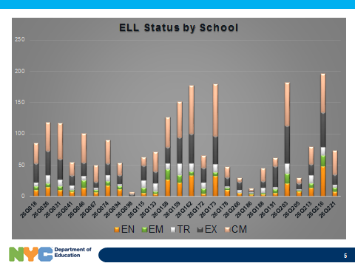 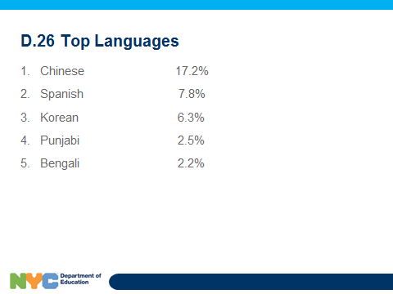

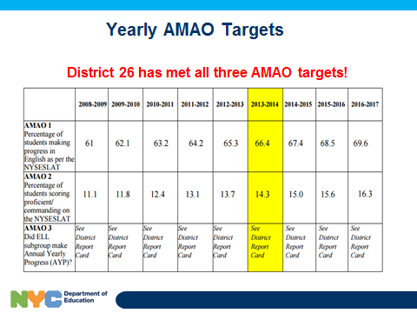 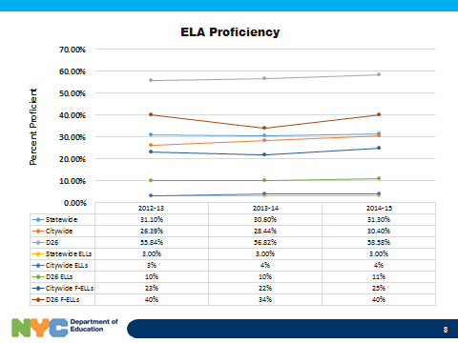

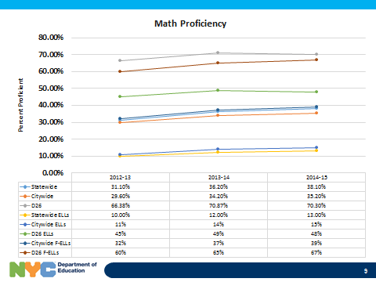 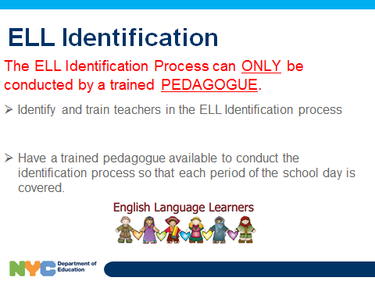

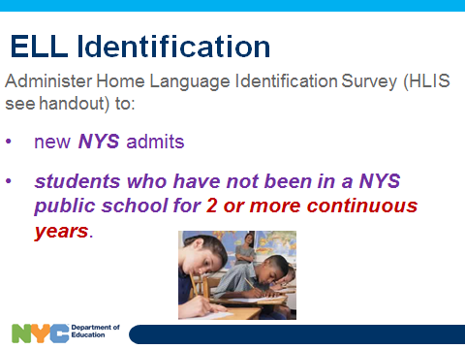 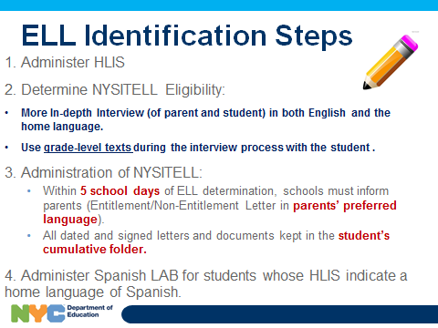

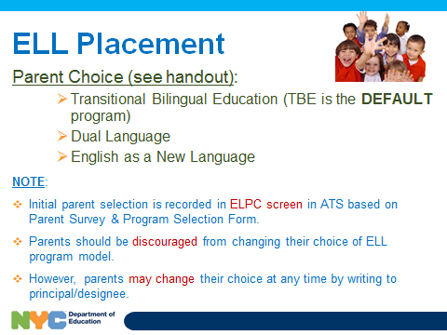 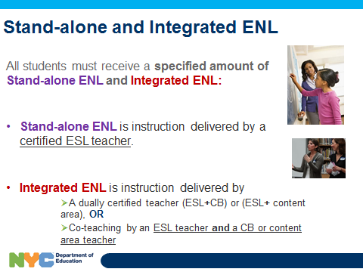

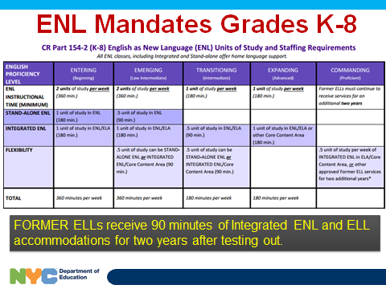 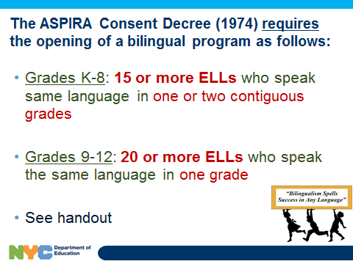

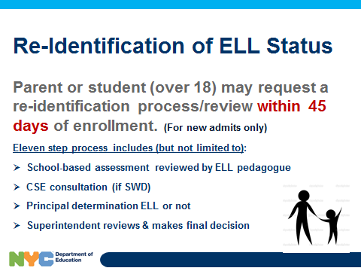 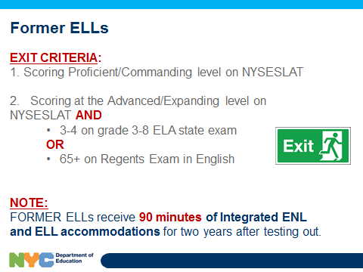

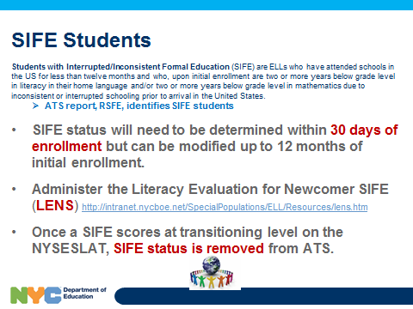 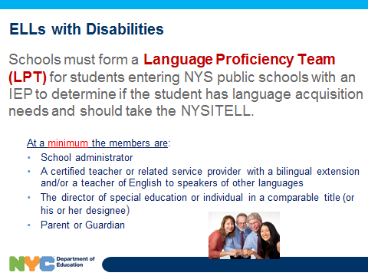

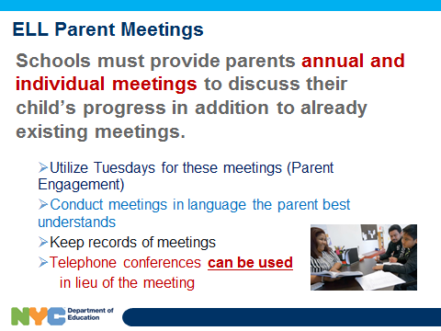 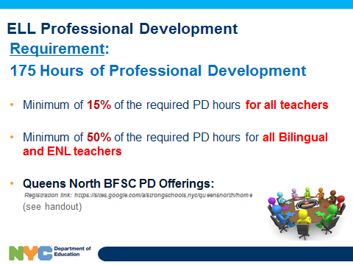

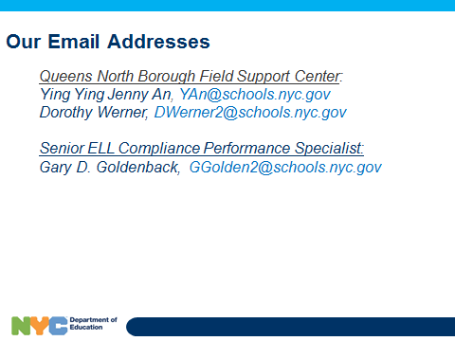

**Addendum 2:**

**2015-2016 Budget Report, March 28, 2016**

**Our opening balance is: $16,686.09**

**Our closing balance is: $11,961.64**

**Reimbursements for workshops: $527.44**

**Copier:** $1,947 **Printer:** $847.00

P-Card Expenses: $1,403.01

**Total Expenditure: $4,724.45**

**Detailed Items**

|  |  |
| --- | --- |
| **March Workshop/Supplies and P-Card Log** | **Amount** |
| 2/25 CEC meeting food | $108.00 |
| 03/02/2016 Developing your Voice Workshop | $55.97 |
| 02/24/2016 Developing your voice workshop | $73.25 |
| 2/2/2016 Nourish your Family Workshop | $135.10 |
| 02/24/2016 PTA Professional Developments | $57.55 |
| 02/24/2016 Developing your voice workshop | $75.59 |
| 2/24/2016 Professional Development for PTA | $21.98 |
| CDEC Copier | $1,947.00 |
| CDEC Printer | $847.00 |
| **P-Card Log** |  |
| Books/How to talk to kids so kids will speak with you | $186.40 |
| Books/How to talk to kids so kids will speak with you | $46.60 |
| Books/How to talk to kids so kids will speak with you | $512.60 |
| CDEC26 Supplies for District Office, Workshop and CEC office | $485.01 |
| CDEC26 Website | $158.49 |
| Clicker for Power Point Presentation | $13.91 |
| **Total** | **$4,724.45** |

**Review of Budget**

|  |  |  |  |
| --- | --- | --- | --- |
|  | **Allocated** | **Committed** | **Balance** |
| **Non Contractual Services(Copier) Object Code 433** | **$1,947.00** | **$1,947.00** | **$0.00** |
| **Non Contractual Services lead (member reimbursable) Object Code 496** | **$1,000.00** | **$0.00** | **$1,000.00** |
| **P-Card/Office Supplies** | **$8,828.00** | **$1,403.01** | **$7,424.99** |
| **Supplies General (Workshops)** | **$2,128.00** | **$1,261.68** | **$866.32** |
| **Transportation of Staff** | **$5,000.00** | **$3,176.67** | **$1,823.33** |
| **Professional Service** | **$250.00** | **$250.00** | **$0.00** |
| **Printer** | **$847.00** | **$847.00** | **$0.00** |
| **Total Expense** | **$8,038.36** |
| **Balance in Budget** | **$11,961.64** |