** Community District Education Council 26**

**New York City Department of Education**

***Address:* 61-15 Oceania Street, Bayside, NY 11364 *Phone:*  (718) 631-6927 *Fax:* (718) 631-1347 *E-mail:* CEC26@schools.nyc.gov.**

**Alan Ong (Borough Appointee) Wendy Pelle-Beer Roy Mendez Leslie Rubenstein Michelle Liu**

*President of the Council First Vice President**Second Vice President**Recording Secretary Treasurer*

*Council Members:* **J Danielle Giunta h Chin**

**Shajid Ali Mohammed Bobby Thind Community Superintendent**

**Dilip Nath David Wong District 26**

**Evelyn Schechter (Borough Appointee)** **Shengchao Yu**

**John Gandelman**

**Community Education Council District 26 (CDEC26) Minutes**

**October 13, 2016**

**Location: M.S. 74 61-15 Oceania Street, Queens, NY 1136**

**Calendar Meeting**

1. ***CDEC26 meeting called to order and roll call at: 7:11 P.M.***

**Present**: Alan Ong (President), Roy Menéndez, Evelyn Schechter, Bobby Thind, Shengchao Yu, Michelle Liu(Treasurer), John Gandelman (Student Member)

**Absent**: Wendy Pelle-Beer (unexcused), Shajid Ali Mohammed (Excused), Dilip Nath (excused), Leslie Rubenstein(unexcused), David Wong (unexcused).

**Also Present**: Danielle Giunta, Superintendent District 26 and Kim D’Angelo.

1. **Office of Space Planning:** Corona Albery & Theodore Pearson presented information about the process of rezoning and the roles of space planning. *Please see Addendum A.*
2. **Superintendent’s Report: Superintendent Danielle Giunta presented Contracts for Excellence.** *Please see Addendum B.*
3. **Public Comments:**
4. ***Roy Mendez moved to adjourn the meeting at 8:16. CM Tarvinder Thind seconded the motion. All were in favor.***

**Community Education Council District 26 (CDEC26) Minutes**

**October 13, 2016**

**Location: M.S. 74 61-15 Oceania Street, Queens, NY 1136**

**Business Meeting**

1. ***Meeting called to order and roll call at 8:18 PM***.

**Present**: Alan Ong (President), Roy Menéndez, Evelyn Schechter, Bobby Thind, Shengchao Yu, Michelle Liu(Treasurer), John Gandelman (Student Member)

**Absent**: Wendy Pelle-Beer (unexcused), Shajid Ali Mohammed (Excused), Dilip Nath (excused), Leslie Rubenstein(unexcused), David Wong (unexcused).

**Also Present**: Danielle Giunta, Superintendent District 26 and Kim D’Angelo.

1. **Approval of September minutes:** CM Tarvinder Thind (Bobby) motioned to approve the November minutes and seconded by CM Evelyn Schechter. Motion passed unanimously.
2. **Budget Report:** *Please see Addendum C.*
3. **President’s Report:**
4. Alan Ong introduced newly appointed CDEC26 Student Member Joseph Gandelman to the community.
5. Chinese American Association Dinner-Principal Molly Wang and Superintendent Giunta are being honored. Please attend the even if you are available.
6. FACE is hosting Citywide Conference for ELL Middle School students and their families. ( information are in members folders )
7. Parent Council Leadership Institute Application are available for CEC executive officers.
8. 3rd Annual Children’s Holiday Parade- Sunday December 4th (flyers are in members folders)
9. **Committee Reports:**
10. **Meeting Adjournment: *Roy Mendez moved to adjourn the meeting at 8:46. CM Tarvinder Thind seconded the motion. All were in favor.***

**Respectfully Submitted by:**

**Farjana Faruk**

**Addendum A:**

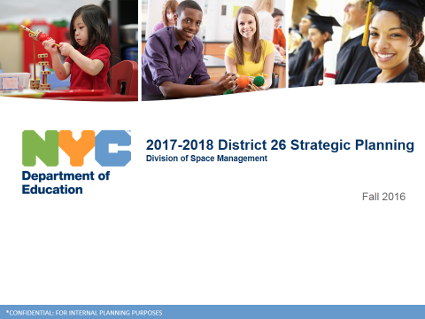 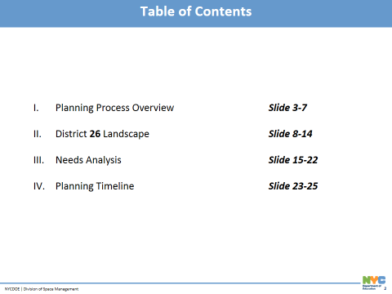

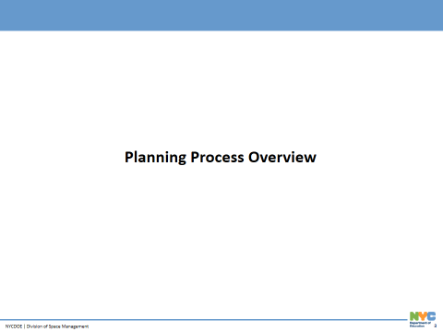 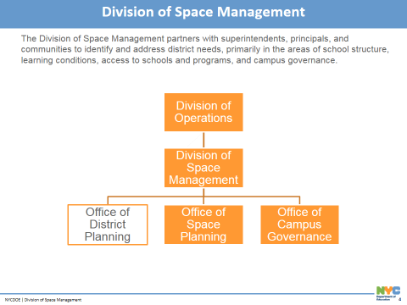

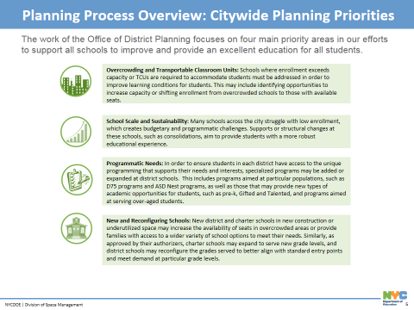 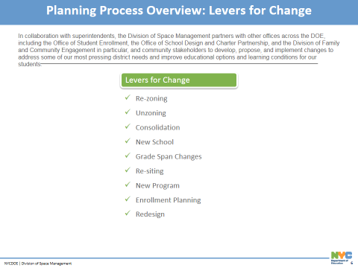

 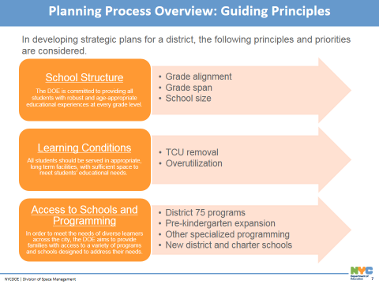

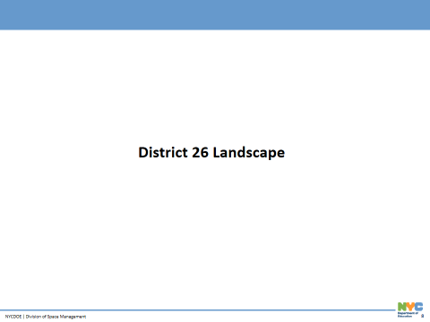 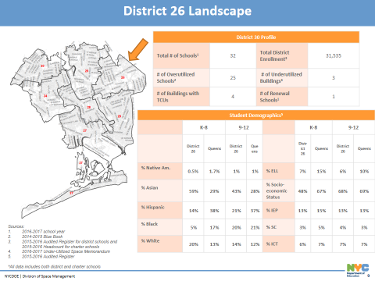

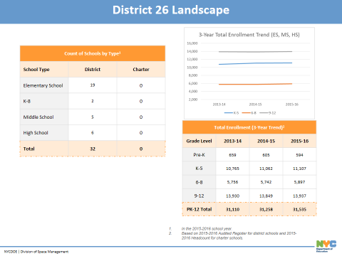 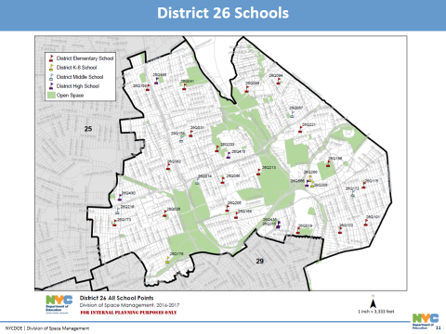

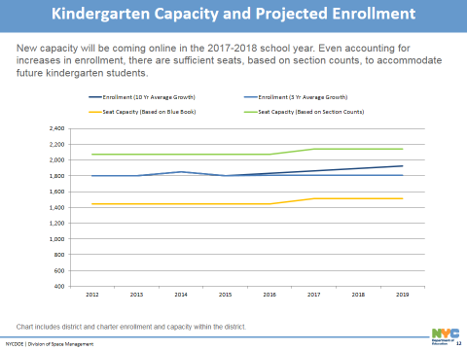 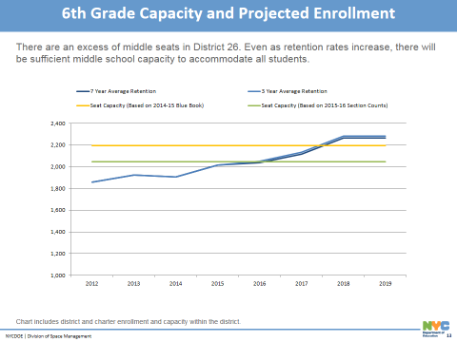

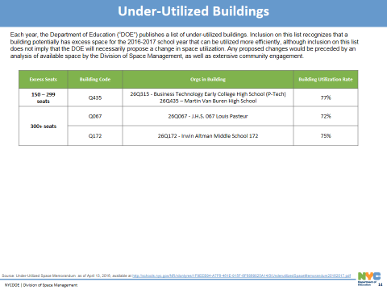 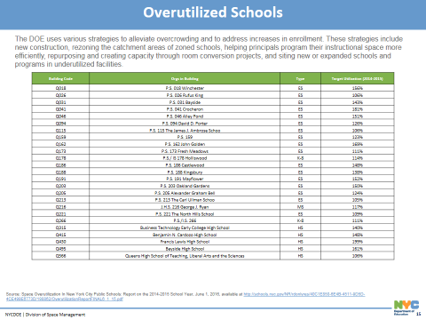

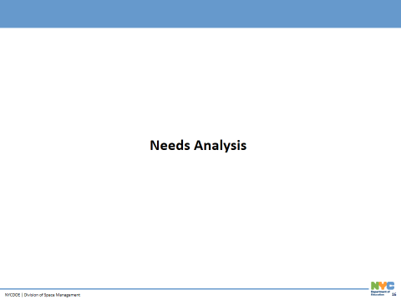 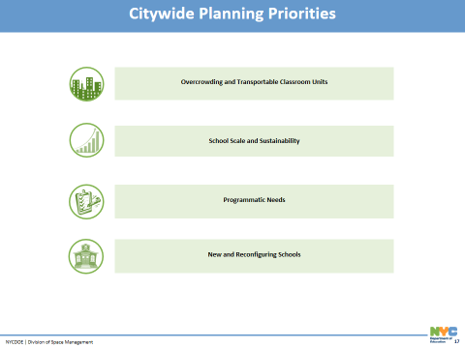

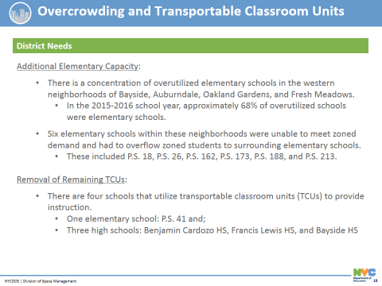 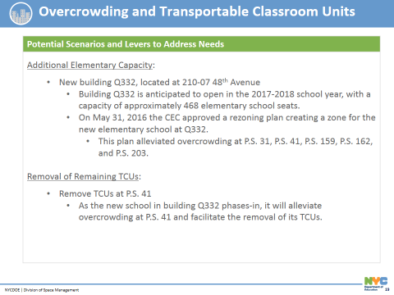

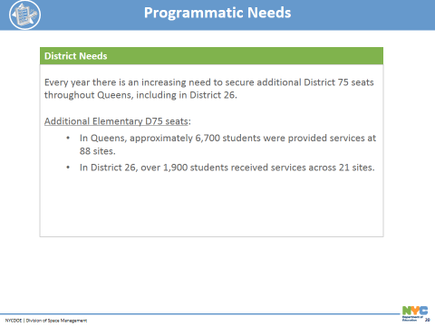 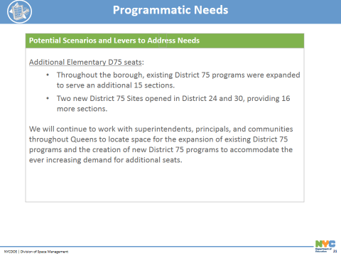

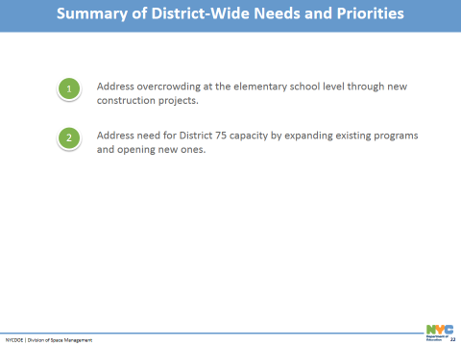 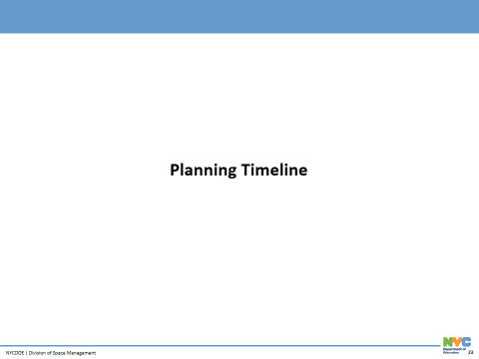

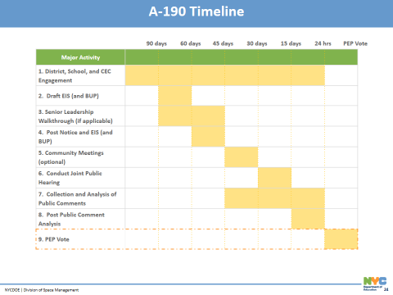 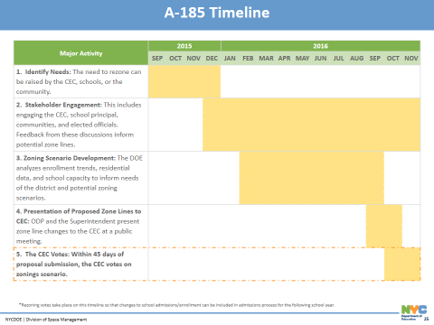

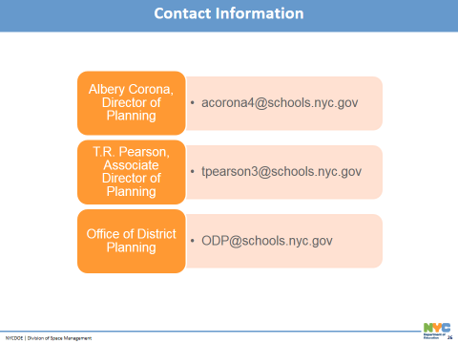 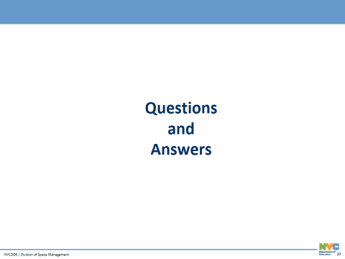

**Addendum B:**

 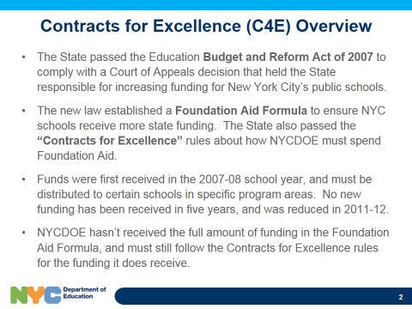

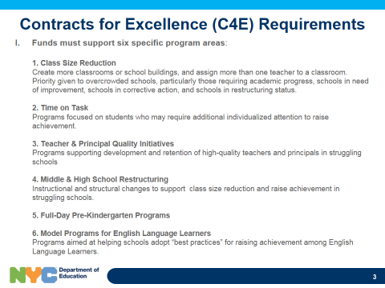 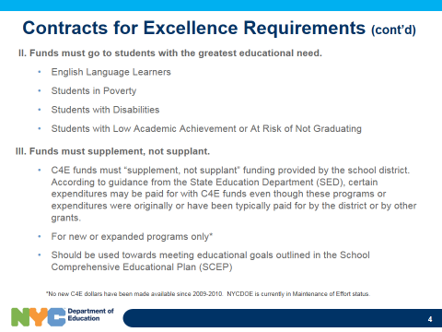

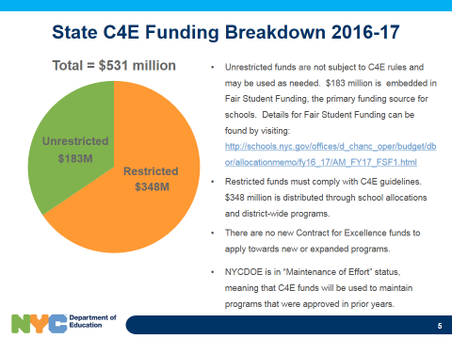 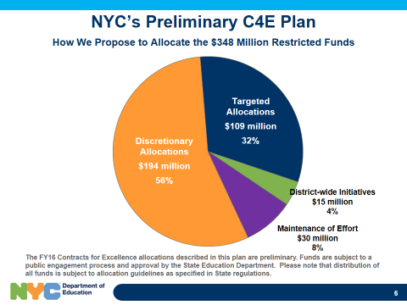

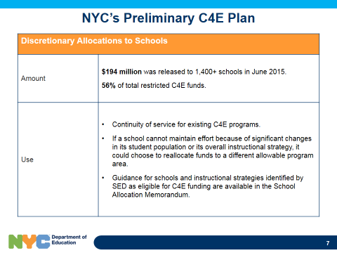 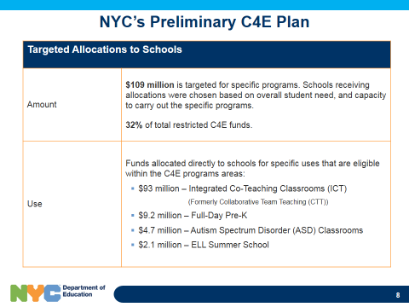

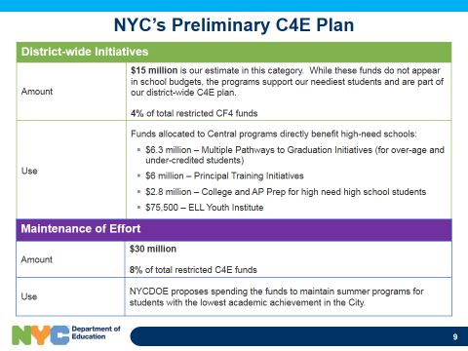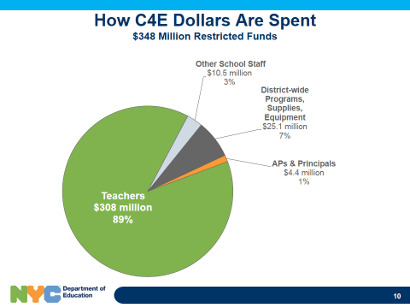

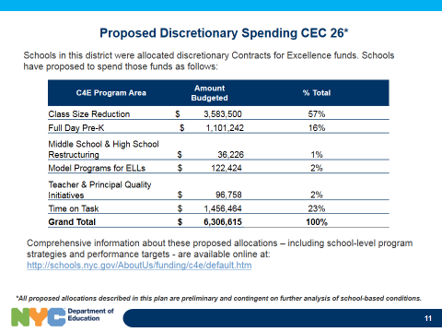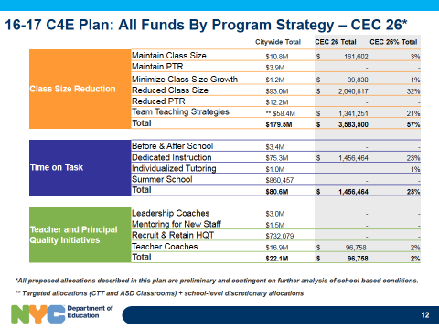

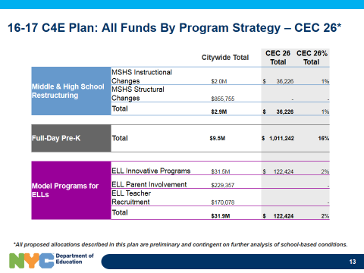 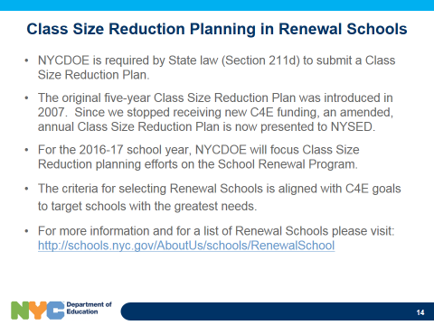

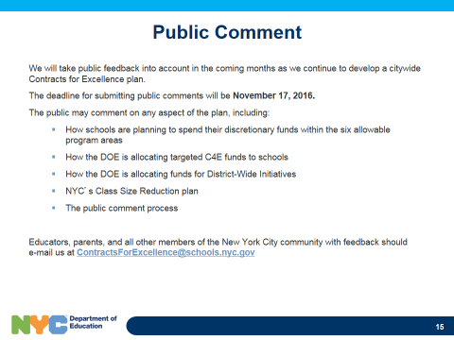

**Addendum C:**

Community Education Council District 26

**2016-2017 Budget Report, October 13, 2016**

**Our opening balance is: $17,505.84**

**Our closing balance is: $15,817.14**

**Detailed Items of spending for October:**

|  |  |
| --- | --- |
| **P-Card** |  |
|  | **Amount** |
| Light Refreshments for October Meeting/ Key Food | $18.13 |
| Light Refreshments for October Meeting/ Fresco Pizzeria | $120.00 |
| **Total:** | **$138.13** |
|  |  |
|  |  |
| **Workshop Light Refreshments** | **Amount** |
| 07/27/16 Yoga Workshop | $61.39 |
| 08/04/2016 Meet and Greet District 26 PTA | $79.51 |
| 08/02/2016 The art of playing bridge | $48.92 |
| 09/14/2016 PTA orientation | $47.38 |
| 07/18/2016 Drawing and Painting from Nature Workshop | $73.18 |
| 07/19/2016 The art of playing bridge | $35.54 |
| 07/20/2016 Yoga Workshop | $21.89 |
| 7/21/2016 nurturing your child with Autism | $31.77 |
| 07/26/2016 Drawing and Painting from Nature | $70.65 |
| 07/26/2016 The art of playing bridge | $47.80 |
| 07/12/2016 The art of playing bridge | $80.00 |
| 07/13/2016 Yoga Workshop | $75.09 |
| 09/13/2016 PTA orientation workshop | $28.15 |
| 09/27/2016 CDEC Meeting Food | $800.00 |
| **Total:** | **$1,501.27** |
|  |  |
|  |  |
| **Member Reimbursements** | **Amount** |
| Roy Menendez | **$49.30** |

**Balance:**

|  |  |  |  |  |  |
| --- | --- | --- | --- | --- | --- |
|  | **Allocated** | **Sept** | **Oct** | **Committed** | **Balance** |
| **Non Contractual Services(Copier) Object Code 433** | **$2,172.00** | $2,172.00 |  | **$2,172.00** | **$0.00** |
| **Non Contractual Services lead (member reimbursable) Object Code 496** | **$1,000.00** |  | $49.30 | **$49.30** | **$950.70** |
| **P-Card/Office Supplies** | **$8,328.00** |  | $138.13 | **$138.13** | **$8,189.87** |
| **Supplies General (Workshops)** | **$600.00** | $101.40 |  | **$101.40** | **$498.60** |
| **Transportation of Staff** | **$5,000.00** | $220.76 | $1,501.27 | **$1,722.03** | **$3,277.97** |
| **Computer** | **$2,300.00** |  |  | **$0.00** | **$2,300.00** |
| **Water for office** | **$600.00** |  |  | **$0.00** | **$600.00** |
| **Total** | **$20,000.00** | **$2,494.16** | **$1,688.70** |  |  |
| **Total Spent** | **$4,182.86** |  |  | **$4,182.86** |  |
| **Balance in Budget** | **$15,817.14** |  |  |  |  |