

**Community District Education Council 26**

**New York City Department of Education**

***Address:* 61-15 Oceania Street, Bayside, NY 11364 *Phone:*  (718) 631-6927 *Fax:* (718) 631-1347 *E-mail:* CEC26@schools.nyc.gov.**

**Alan Ong John Gavros Roy Menendez Adriana Aviles David Wong**

*President of the Council First Vice- President**Second Vice President**Recording Secretary Treasurer*

*Council Members:* **J Danielle Giunta h Chin**

**Sheng Chao Yu Michelle Liu Community Superintendent**

**Dilip Nath Shajid Ali Muhamad District 26**

**Karen Rose Scutt**  **Tanweer Ansari**

**Website: www.CDEC26.org**

**April 26, 2018 Calendar Meeting Minutes**

**Calendar Meeting: 7:12 PM**

**Meeting called to Order and Roll Call at 7:12 PM by Alan Ong.**

**Present**:  Alan Ong, John Gavros, Roy Menendez, David Wong, Shengchao Yu, Karen Rose Scott, Dilip Nath, Michelle Liu and Adriana Aviles

**Absent:**  Shajid Ali Muhammad (excused), Tanweer Ansari (excused)

**Also Present**:  Danielle Giunta, Superintendent District 26, Lori Stein Butera, Farjana Faruk and Paola deKock

1. **Welcome**
2. **Presentation by School Food ( Dennis Mueller)**
3. Garden to Café Program
4. Thursday Menu is New York based products. They are made or grown in New York State
5. Our foods have no antibiotic and no preservation in the food.
6. All school must have working water fountain. If not, please contact school food.
7. There are food safety protocols which is shared with the CEC members.
8. Several times a school year, we visit schools and check to make sure foods are properly served. Every day school cafeteria has to log temperature of the foods right before they are cooked.
9. The menus are made by the office of Food & Management groups. It’s a citywide menu. Salad bars should be available every day.
10. PS 31 has breakfast in classroom.
11. For halal foods concern, we also offer hummus and pretzels in additions to peanut butter sandwich.
12. State has to approve menu for school food. School food always have a vegetarian menu. We can try working with school schools to change it little bit but the foods that are served takes about a year for ingredient to approve.
13. **Middle School Survey Result:**  Please see addendum A.

* Discussion took place regarding G&T program for middle school and 2020 changes, regents procedures for middle schools, computer science access to middle school students.

1. **Superintendent’s Report:**
2. New Chancellor Richard Carranza’s visit to District 26.
3. Critical importance of Computer Science
4. Increasing funding for all schools to 90%.
5. **Public Comment:**
6. Suzanne from CM Grodenchik office shared information regarding upcoming events.
7. **Superintendent’s Report:**  Danielle Giunta
8. District 26 FY 2019 School Budgeting Allocation Formula: (see ***addendum B****)* for detailed overview.
9. The councilmembers highlighted and discussed about the accomplishment for our monthly District 26 Spotlight Schools.
10. CPAC- A660 was renewed. Flushing High School have been restaffed. School surveys are due.

Alan Ong made a motion to adjourn the public meeting. Seconded by John Gavros. Motion passed unanimously. Meeting adjourned at 8:30 pm.

**April 26, 2018**

**Business Meeting**

**Meeting called to Order and Roll Call at 8:32 PM by Alan Ong**.

**Present**:  Alan Ong, John Gavros, Roy Menendez, David Wong, Shengchao Yu, Karen Rose Scott, Dilip Nath, Michelle Liu and Adriana Aviles.

**Absent:** Shajid Ali Muhamad (excused), Tanweer Ansari (excused)

**Also Present**:  Danielle Giunta, Superintendent District 26, Lori Stein Butera, Farjana Faruk and Paola deKock

1. **Minutes** was reviewed for February 22, 2018 Motion was made by John Gavros to approve the minutes and seconded by David Wong. Motion passed unanimously for approval of minutes.
2. **Budget Review-** Budget was reviewed. Motion to approve John Gavros and seconded by Shengchao Yu
3. **Approval of Funding and Support for Foreign Language Instruction:**

Motion was made by Alan Ong and seconded by Michelle Liu. Motion passed unanimously.

1. Michelle Liu also motioned to create a Dual Language Committee. Alan Ong appointed Co-Chairs as Michelle Liu and Shengchao Yu.
2. **President’s Report- Alan Ong**

* **Discussion took place regarding absence and bylaws**.
* A idea and request for safety protocol was presented by Adriana Aviles. Discussion took place regarding safety protocol and CEC26 decided to create a resolution to be presented for approval.

1. Old Business
2. New Business
3. Alan Ong motioned to adjourn the meeting at 9:30 PM.

**Absence:**

On Wed, Apr 25, 2018 at 11:10 AM, Tanweer Ansari <[tanweer.ansari@fnbli.com](mailto:tanweer.ansari@fnbli.com)> wrote:

Alan and Farjana,

Please excuse me for tomorrow’s meeting as I have a necessary speaking engagement at the same time.  I am sorry for the late notice, as I was trying to get out of the engagement.

**Shajid Ali Muhammad-** Notified Alan Ong of being absence due to work related issues.

**Addendum A:**

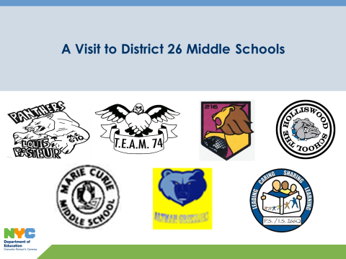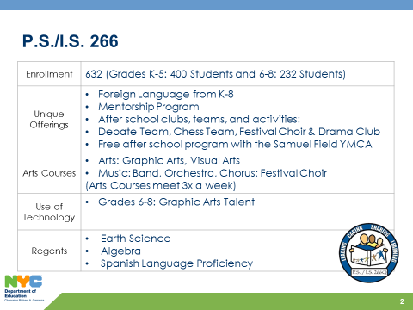

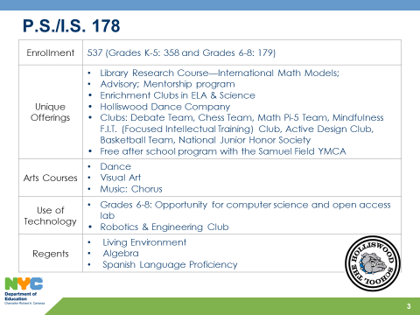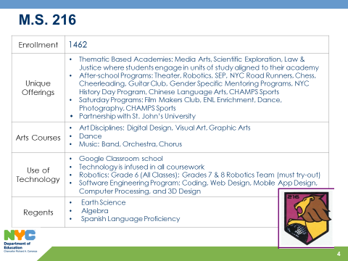

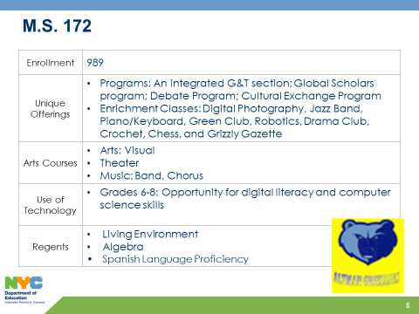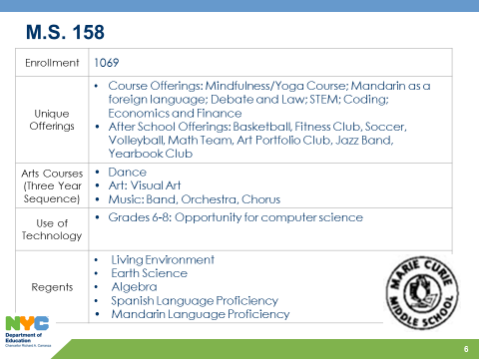

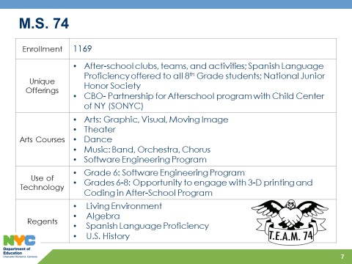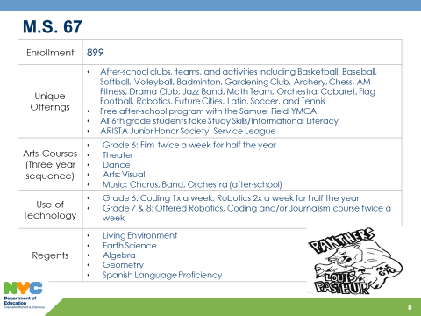

**Addendum B:**

|  |  |  |  |  |  |  |  |  |  |  |  |
| --- | --- | --- | --- | --- | --- | --- | --- | --- | --- | --- | --- |
|  | **Allocated** | **Sept** | **Oct** | **Nov** | **Dec** | **Jan** | **Feb** | **Mar** | **Apr** | **Total & Committed** | **Balance** |
| **Non Contractual Services(Copier) Object Code 433** | **$2,172.00** | $2,172.00 |  |  |  |  |  |  |  | **$2,172.00** | **$0.00** |
| **Member Reimbursement Object Code 496** | **$1,000.00** | $30.00 |  |  |  |  |  |  |  | **$30.00** | **$970.00** |
| **P-Card/Office Supplies** | **$13,196.00** | $105.27 | $409.61 | $239.83 | $247.51 | $522.89 | $366.59 |  | $1,848.04 | **$3,739.74** | **$9,456.26** |
| **Supplies General (Workshops) Object Code 198** | **$0.00** |  |  |  | $0.00 |  |  |  |  | **$0.00** | **$0.00** |
| **Workshop & Transportation of Staff** | **$1,548.00** | $465.49 | $89.31 |  |  | **$593.22** |  |  |  | **$1,148.02** | **$399.98** |
| **Furniture** | **$1,176.00** |  |  |  |  | **$1,176.00** |  |  |  | **$1,176.00** | **$0.00** |
| **Vendor Payment for Workshops** | **$500.00** |  |  |  |  | **$500.00** |  |  |  | **$500.00** | **$0.00** |
| **Water for office** | **$408.00** |  | $407.52 |  |  |  |  |  |  | **$407.52** | **$0.48** |
| **Total** | **$20,000.00** | **$2,772.76** | **$906.44** | **$239.83** | **$247.51** | **$2,792.11** | **$366.59** | **$0.00** | **$1,848.04** |  |  |
| **Total Spent** | **$8,265.76** |  |  |  |  |  |  |  |  | **$9,173.28** |  |
| **Balance in Budget** | **$10,826.72** |  |  |  |  |  |  |  |  |  |  |