**Joint Meeting Minutes**

**Community District Education Council 26 (CEC26)**

**President Council District 26 (PCD26)**

**New York City Department of Education**

***Address:* 61-15 Oceania Street, Bayside, NY 11364 *Phone:*  (718) 631-6927 *Fax:* (718) 631-1347 *E-mail:*** [**CEC26@schools.nyc.gov**](mailto:CEC26@schools.nyc.gov)**.**

*Council Members:* **J Danielle Giunta h Chin**

**Alan Ong Michelle Liu Tanweer Ansari Community Superintendent**

**Dilip Nath David Wong District 26**

**John Gavros**  **Shengchao Yu**

**Karen Rose Scutt Adriana Aviles**  **Website: www.cdec26.org**

**March 28, 2019**

**Calendar Meeting- 7:00 PM**

**Meeting called to Order and Roll Call at 7:05 PM by Alan Ong.**

**Present**:  Alan Ong (President), Karen Rose Scutt, Shengchao Yu, David Wong ,John Gavros, Michelle Liu, Shajid Ali Muhammad, Adriana Aviles, Roy Menendez , Dilip Nath, Tanweer Ansari

**Absent**:   
**Also Present**:  Superintendent Danielle Giunta, Dr. Tara Davidson, Kimberly D’Angelo District 26 Family Leadership Coordinator, Wendy Mo and Farjana Faruk.

1. **Superintendent’s Report-**

* Superintendent Giunta welcomed D26 community. She also introduced Dr. Tara Davidson, newly appointed Deputy Superintendent D26.
* She shared information about Queens Fun Run and March 19th STEM night.
* Deepening Leadership- concept of advanced literacy across the district to improve diversity and multi-lingual community to thrive together. We are sharing a new form of learning system which will be presented at upcoming meetings by Principal Laporte, Principal Anello, AP Tang and Ms. Hauffman.
* Kim D’Angelo shared information with council about upcoming workshop and programs for parents across District 26.

1. **FY 2020 Fair Student Funding Presentation**- **See addendum A**.

* CEC26 member asked information regarding extra funding for G&T, renewal schools in D26, new program for
* Brian Chen broke down each allocation of funding and explained to CEC members how funds are allocated through Fair Student Funding.
* Time line of the budget was shared of approval of the budget and any member of the community can submit public comments.
* Council asked information on data of charter schools and students being served in charter school and why is the cost of maintaining charter schools are so high compare to our public schools?

1. **Public Comment –**

* Mary Vaccaro-shared information about upcoming lobby day and fighting for money for D26. D26 will be part of March Madness.
* James Gallagher- shared information about organic recycling, issues at Arby’s and students from HS, free tour for Cunningham Park, fresh meadow library workshops and Chess tournament in partnership with 107 precinct.

1. Alan Ong shared information about upcoming CEC election and that any parents can apply to CEC. Application is due on March 6th.

John Gavros motioned to adjourn meeting. Motion passed unanimously. Meeting Adjourned at 8:40 PM.

**January 31, 2019**

**Calendar Meeting- 8:50 PM**

**Meeting called to Order and Roll Call at 8:50 PM by Alan Ong.**

**Present**:  Alan Ong (President), Karen Rose Scutt, Shengchao Yu, David Wong ,John Gavros, Michelle Liu, Shajid Ali Muhammad, Adriana Aviles, Roy Menendez , Dilip Nath

**Absent**:   
**Also Present**:  Superintendent Danielle Giunta, Dr. Tara Davidson, Kimberly D’Angelo District 26 Family Leadership Coordinator, Wendy Mo and Farjana Faruk.

1. Meeting was called to order by Alan Ong 8:50 PM.
2. Motion was made by Alan Ong for approval of January 31, 2019 minutes. Motion was approved unanimously.
3. David Wong shared information about balance in the budget and reviewed. Council approved budget unanimously.
4. Budget Modification was discussed. David Wong motioned to approve budget modification. Budget modification approved unanimously**. Please see addendum B.**
5. District Spotlight School visit and upcoming Spotlight School PS 376.
6. CEC26 members voted and approved unanimously on Marian Mason Perseverance Award (1 boy) and 1 (girl) and annual Ballroom Dancing for May 30th. They approved to keep the same structure as past year.
7. Anti-Bullying workshop- CEC26 members discussed upcoming cyberbullying/ anti-bullying workshop in June. They discussed type of speakers and format they would like to see for both parents and kids. They discussed that the bullying workshop should focused on the parents and child working together to recognize bullying and distinguishing bullying.
8. Committee Report- Adriana gave an update on scheduling capital plan committee meeting.
9. Shengchao Yu- raised a concern at P.S. 203 and bussing issues.

Adjournment: Alan Ong made a motion to adjourn. John Gavros seconded the motion.  All in favor. The meeting adjourned at 10:20 PM.

Absent:

**Addendum A-**

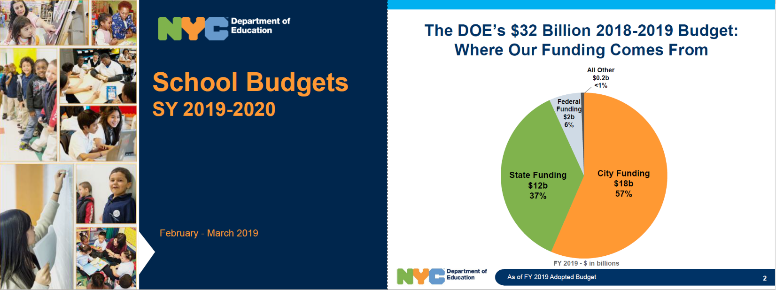

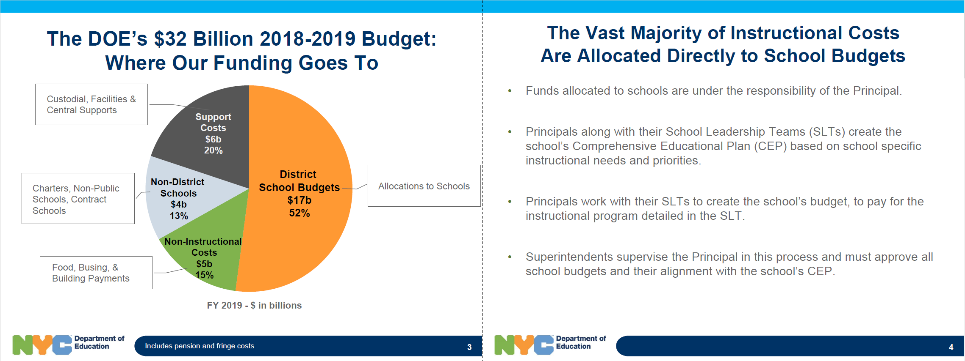

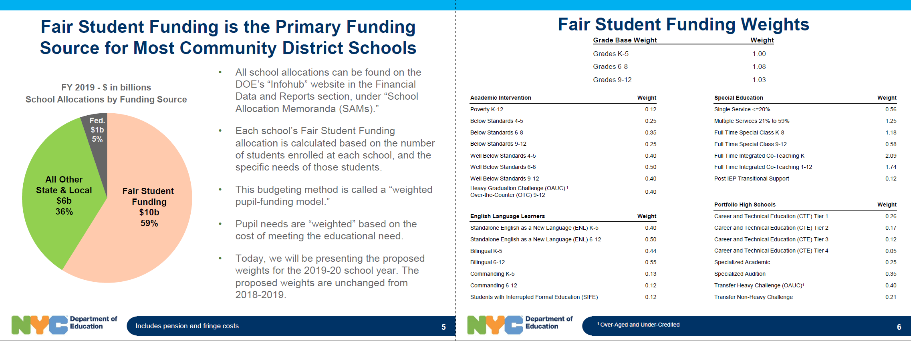

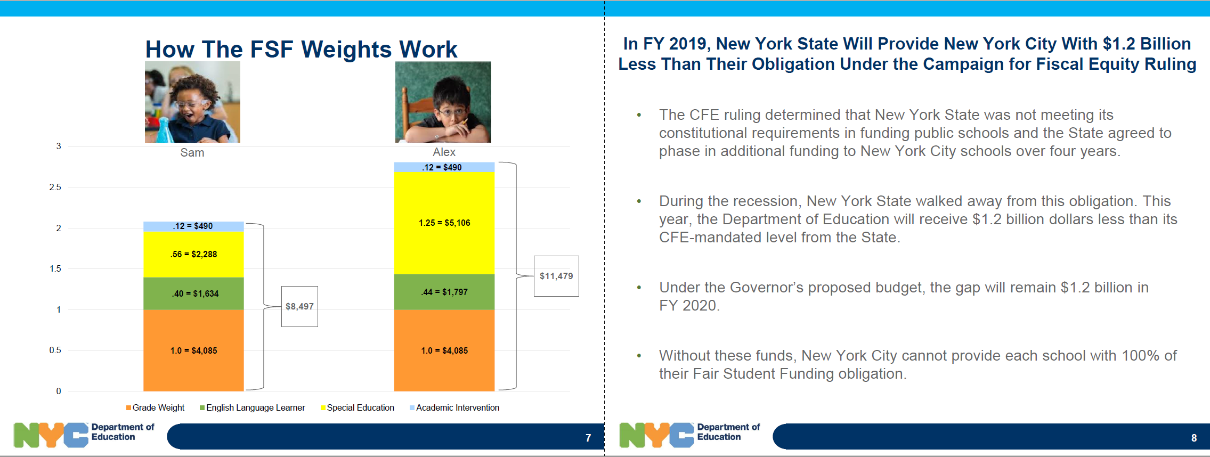

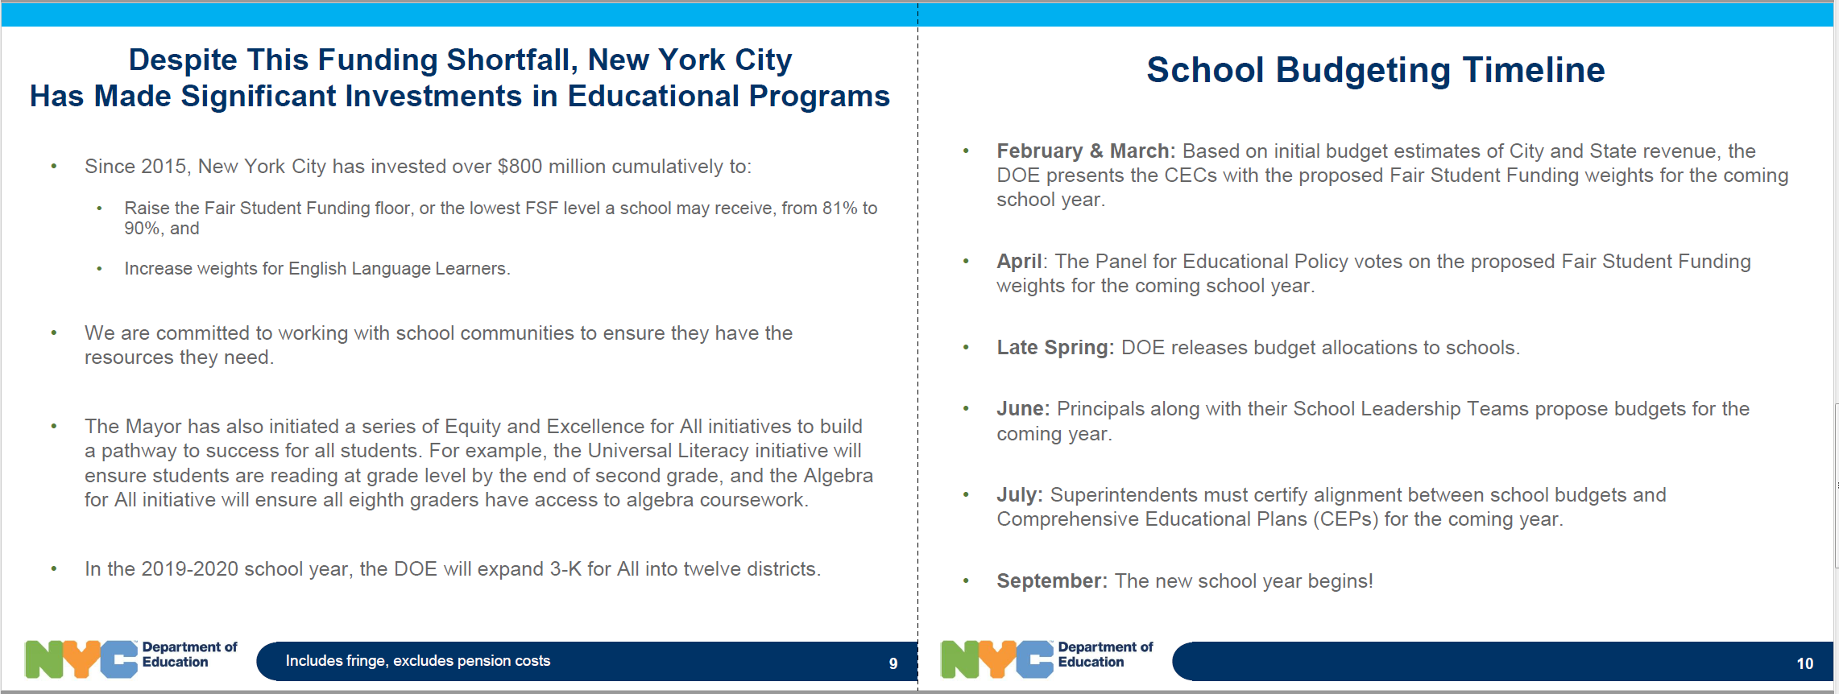

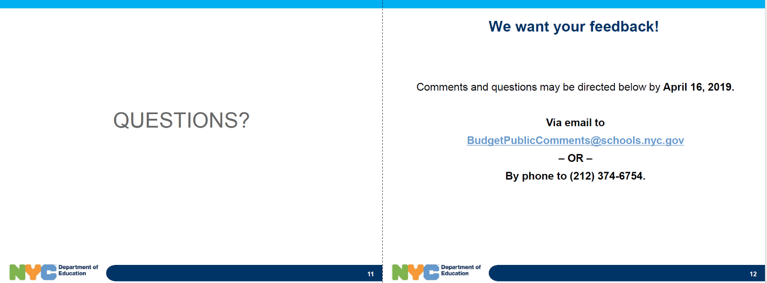

**Addendum B:**

** Community District Education Council 26**

**New York City Department of Education**

***Address:* 61-15 Oceania Street, Bayside, NY 11364 *Phone:*  (718) 631-6927 *Fax:* (718) 631-1347 *E-mail:* CEC26@schools.nyc.gov.**

**February 28, 2019 CEC26 Budget Report**

**Opening balance is- $16,929.76**

**Closing balance is- $16,440.26**

**January Expense** = $489.50 (see next page for details)

|  |  |  |  |  |  |  |  |  |  |
| --- | --- | --- | --- | --- | --- | --- | --- | --- | --- |
|  | **Allocated** | **Sept** | **Oct** | **Nov** | **Dec** | **Jan** | **Total & Committed** | **Balance** | **Object Code** |
| **Non Contractual Services(Copier) Object Code 433** | **$2,172.00** |  |  |  |  |  | **$0.00** | **$2,172.00** | 433 |
| **Member Reimbursement Object Code 496** | **$2,000.00** |  | $331.76 |  | $210.00 | $44.00 | **$585.76** | **$1,414.24** | 496 |
| **P-Card/Office Supplies** | **$5,000.00** |  |  |  |  |  | **$0.00** | **$5,000.00** | 179 |
| **Supplies General (Workshops) Object Code 198** | **$3,000.00** | $114.96 |  | $172.85 |  |  | **$287.81** | **$2,712.19** | 198 |
| **Workshop & Transportation of Staff** | **$5,928.00** | $150.00 | $224.73 | $142.75 | $206.93 | $445.50 | **$1,169.91** | **$4,758.09** | 451 |
| **Furniture** |  |  |  |  |  |  | **$0.00** | **$0.00** | 314 |
| **Vendor Payment for Workshops** | **$1,500.00** | $225.00 | $400.00 | $225.00 | $300.00 |  | **$1,150.00** | **$350.00** |  |
| **Water for office** | **$400.00** | $366.26 |  |  |  |  | **$366.26** | **$33.74** | 403& 198 |

**Detailed**

**Workshop & Transportation of staff-**

|  |  |  |
| --- | --- | --- |
| Bayside Milk Farm | $240.50 | 1/31/2019 CEC26 Meeting |
| Marathon Food | $205.00 | 02/28/2019 CEC26 Meeting |

**Member Reimbursement**

|  |  |  |  |
| --- | --- | --- | --- |
| Adriana Aviles | 01/22/2018 | $44 | Parent Leadership Training 01/22/2019 |

**Budget Modification-**

**New Copier will cost less for the next 3 months. $156 will be removed from copier to be added supplies general.**

Copier NEW balance = $2016

Supplies NEW balance =$2868.19

**Microphone Purchases- New microphones will be purchased at the cost of $625.00 (code 315). Funds are subtracted from member reimbursements (code 496) amount of $625.00.**

Microphone code (315) = $625.00

Member Reimbursement NEW balance= $789.24

**Vendor Payment- For upcoming vendor payment, we need to subtract of $1330 from workshop & food (code 451) add to vendor payment (code 489).**

Vendor Payment NEW balance= $1680

Workshop& transportation NEW balance= $3428.09

**Subtract $170.00 from Workshop and Transportation (code 451) to add to Website Vendor Payment code (686)**

NEW Balance for Workshop& Transportation= $3258.09

Website Payment code (686) = $170.00

**Workshop Estimate Upcoming event food-**

March food estimate $150.00

April food estimate $150.00

May food estimate $ 800.00

June food estimate $205

Bullying workshop food budget-$500

Middle School and Elementary Cohort Parent Workshop- $1250

**Anything additional supplies/promotional items will be purchased through the P-Card remaining balance of $5000.00**

|  |  |  |  |  |  |  |  |  |
| --- | --- | --- | --- | --- | --- | --- | --- | --- |
|  | **Original Allocation** | Total Committed | Balance | **Object Code** | **Adjustment** | **Adjustment 2** | **Modified Balance** | **Modified Final Allocation** |
| **Non Contractual Services(Copier) Object Code 433** | **$2,172.00** | $0.00 | $2,172.00 | **433** | **-$156.00** |  | **$2,016.00** | **$2,016.00** |
| **Member Reimbursement Object Code 496** | **$2,000.00** | $585.76 | $1,414.24 | **496** | **-$625.00** |  | **$789.24** | **$1,375.00** |
| **P-Card/Office Supplies** | **$5,000.00** | $0.00 | $5,000.00 | **179** |  |  | **$5,000.00** | **5000** |
| **Supplies General (Workshops) Object Code 198** | **$3,000.00** | $287.81 | $2,712.19 | **198** | **Add $156.00** |  | **$2,868.19** | **$3,156.00** |
| **Workshop & Transportation of Staff** | **$5,928.00** | $1,169.91 | $4,758.09 | **451** | **-$1,330.00** | **-$170.00** | **$3,258.09** | **$4,428.00** |
| **Microphone Object Code 315** |  | $0.00 | $0.00 | **315** | **Add $625.00** |  | **$625.00** | **$625.00** |
| **Website Payment Object Code 686** |  |  |  |  |  | **Add $170.00** | **$170.00** | **$170.00** |
| **Vendor Payment for Workshops** | **$1,500.00** | $1,150.00 | $350.00 |  | **Add $1330.00** |  | **$1,680.00** | **$2,830.00** |
| **Water for office** | **$400.00** | $366.26 | $33.74 | **403& 198** |  |  | **$33.74** | **$400.00** |
| **Total** | **$20,000.00** |  |  |  |  |  |  |  |
| **Total Spent** | **$3,559.74** | **$3,559.74** |  |  |  |  |  |  |
| **Balance in Budget** | **$16,440.26** |  |  |  |  |  | $16,440.26 | $20,000.00 |

**\*\* Just Note Code 198 might have extra balance over of $33.74 for water payment**