**Join President Council &**

**Community District Education Council 26**

**New York City Department of Education**

***Address:* 61-15 Oceania Street, Bayside, NY 11364 *Phone:*  (718) 631-6927 *Fax:* (718) 631-1347 *E-mail:* CEC26@schools.nyc.gov.**

**November 20, 2019 Calendar Meeting  
Calendar Meeting called to order and roll call at 7:05 PM by Adriana Aviles.**

**Present**:  Alan Ong, Karen Rose Scott, Adriana Aviles, Todd Friedman, Cassandra Louie, Norman Cohn, Dilip Nath, John Gavros, David Wong and Seth Breland

**Absent:**  Sandra Lau (unexcused) Voted – 7 Yes, 1 No (Karen Rose Scutt voted excused)

1. Welcome – Cathy Grodsky & Adriana Aviles
2. Elizabeth Crowley and Assemblywoman Alicia Hyndman brief remarks.
3. **Superintendent Report –** provided update regarding administration and PS 41Q.
4. **Office of Enrollment: (Please see addendum A).** Office of Enrollment provided update on St. Robert property and potential non-zoned elementary school might reduce the congestions some of our schools are facing.
5. **Office of Department of Transportation:** Parent asked questions about PS traffic issues at 26Q, PS 133, PS 186, PS 115 and procedures DOT uses to complete projects. DOT representative Andrew Acrese will follow up CEC with additional answers.
6. **Senator John Liu:** Sen. Liu brief remarks regarding update on D26.
7. **Joint President Council & CEC meeting-**discussed briefly suggestions on goals for upcoming year.
8. **Public Comment:**

* **Mary Vaccaro-** Disc
* **Jim Gallagher**

**November 20, 2019 Business Meeting**

**Business Meeting called to order and roll call at 8:20 PM by Adriana Aviles.**

**Present**:  Alan Ong, Karen Rose Scott, Adriana Aviles, Todd Friedman, Cassandra Louie, Norman Cohn, Dilip Nath, John Gavros, David Wong and Seth Breland

**Absent:** Sandra Lau (unexcused) Voted- 7 Yes, 1 No

**Also Present**:  Superintendent Giunta and District 26 Team

1. **Welcome**
2. **Minutes** was reviewed for October 17, 2019 and motion was made by Adriana Aviles to approve the minutes and seconded by John Gavros. Motion passed unanimously for approval of minutes.
3. **Budget Report** John Gavros presented the budget for the council and motion to approve the budget. They discussed the additional $5,000 that was presented to the Council. Motion to approve by John Gavros and seconded by David Wong to use the funds for workshops, supplies and internet. Motion passed unanimously**.**
4. **President’s Report-**

* School visit form
* Van Burean NASA

1. **Member Report & Committee Report:**
2. Norman Cohn- updated on PS 188, 74Q and PS 205
3. Alan discussed upcoming school visits.
4. Alan Ong gave an update on CEC changes.
5. **Capital Plan:**  Capital Plan procedures was briefly discussed and reviewed.

*Motion for adjournment by Adriana Aviles. Motion approved unanimously at 10:05 PM.*

Absence:

>

> -----Original Message-----

> From: Sandra Y Lau [mailto:sandraylau@gmail.com]

> Sent: Monday, October 21, 2019 2:06 PM

> To: CEC26 D26 <CEC26@schools.nyc.gov>

> Subject: 11/20: absent for CeC meeting

>

> Farjana

> I need to take an absence for 11/20 meeting. I have a yoga training session scheduled for that day and will be unavailable. Thanks Sandra

Addendum A-

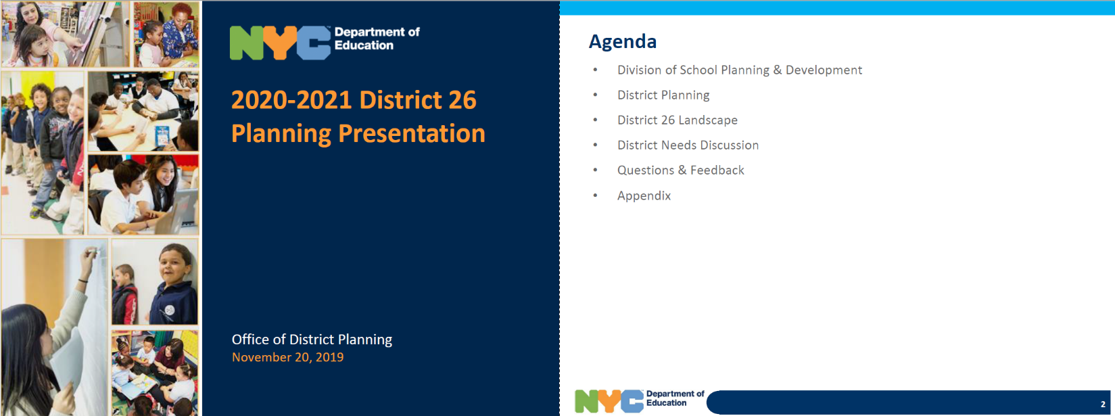

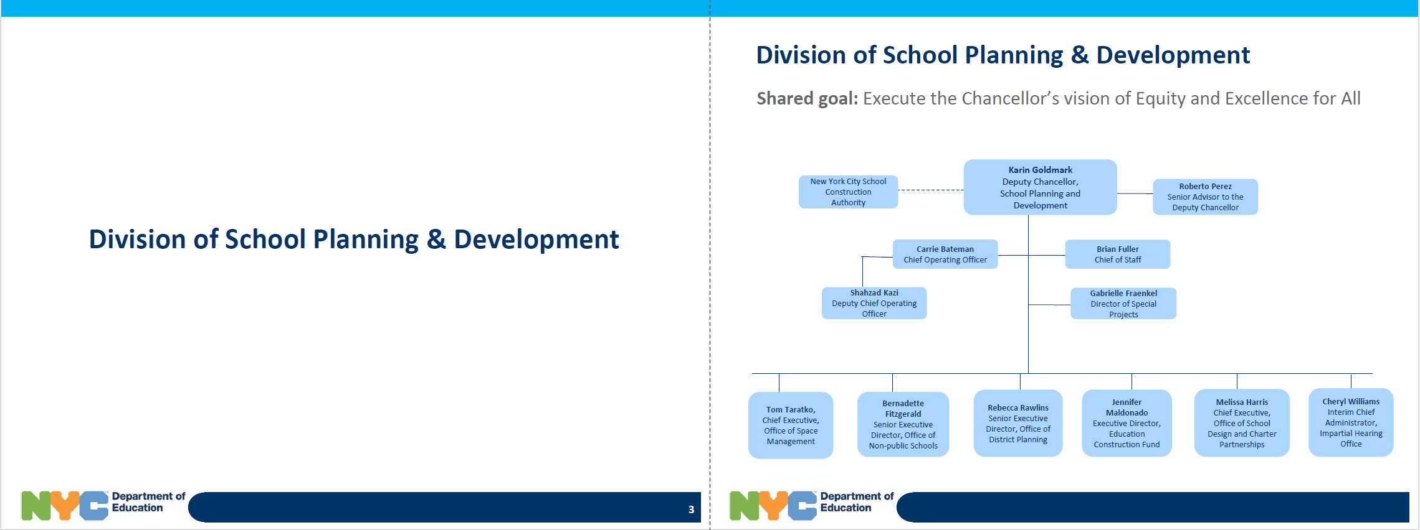

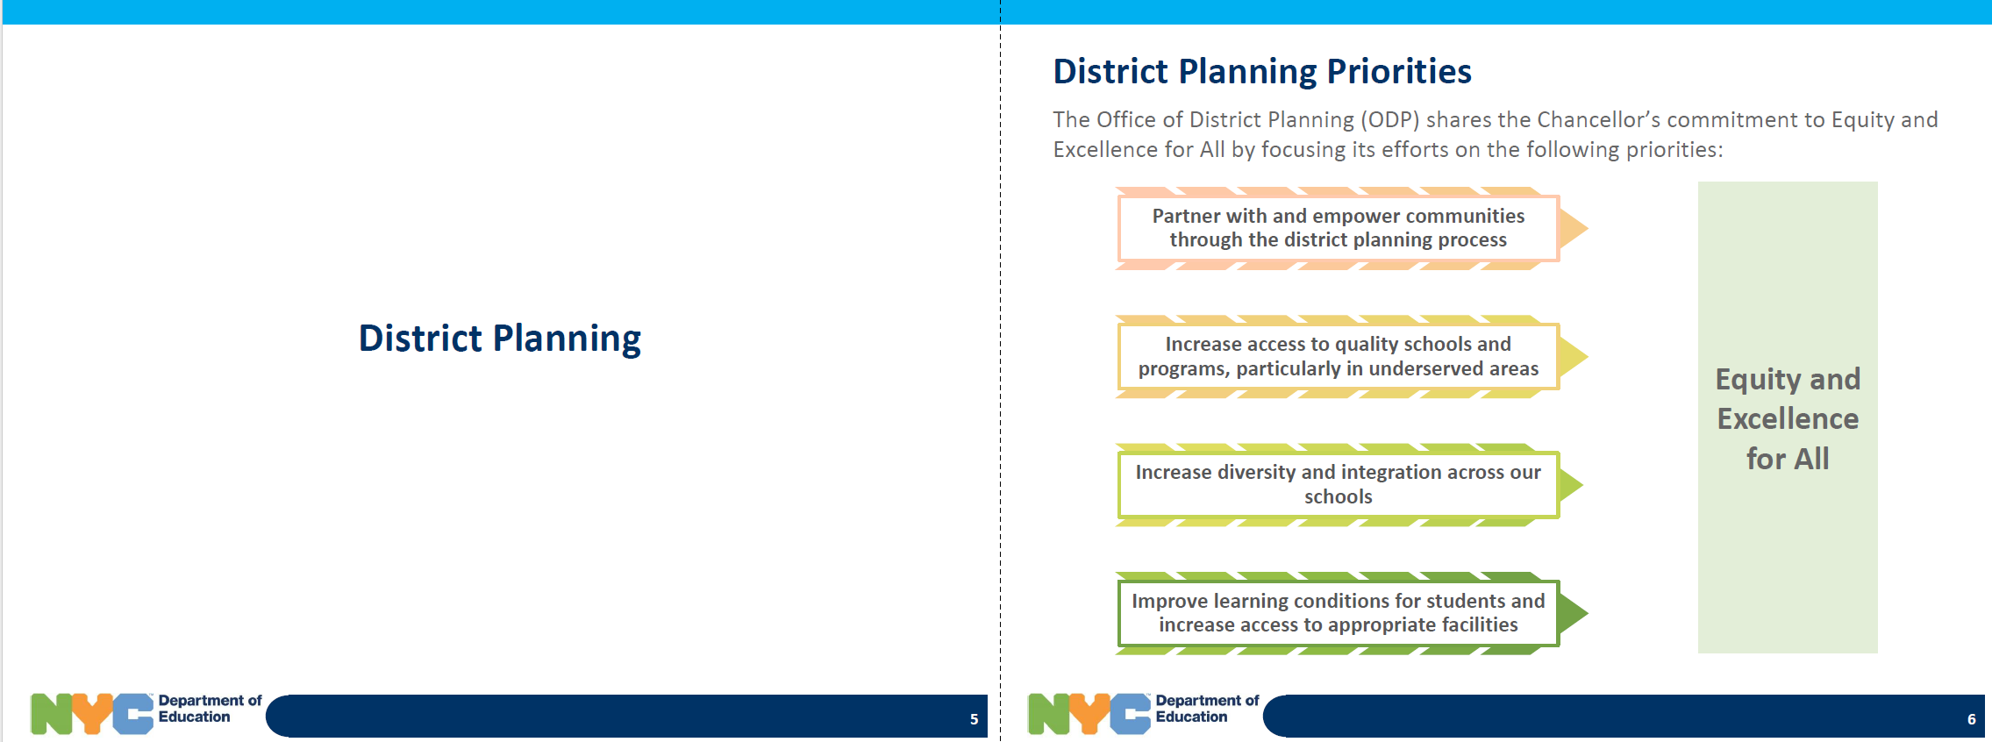

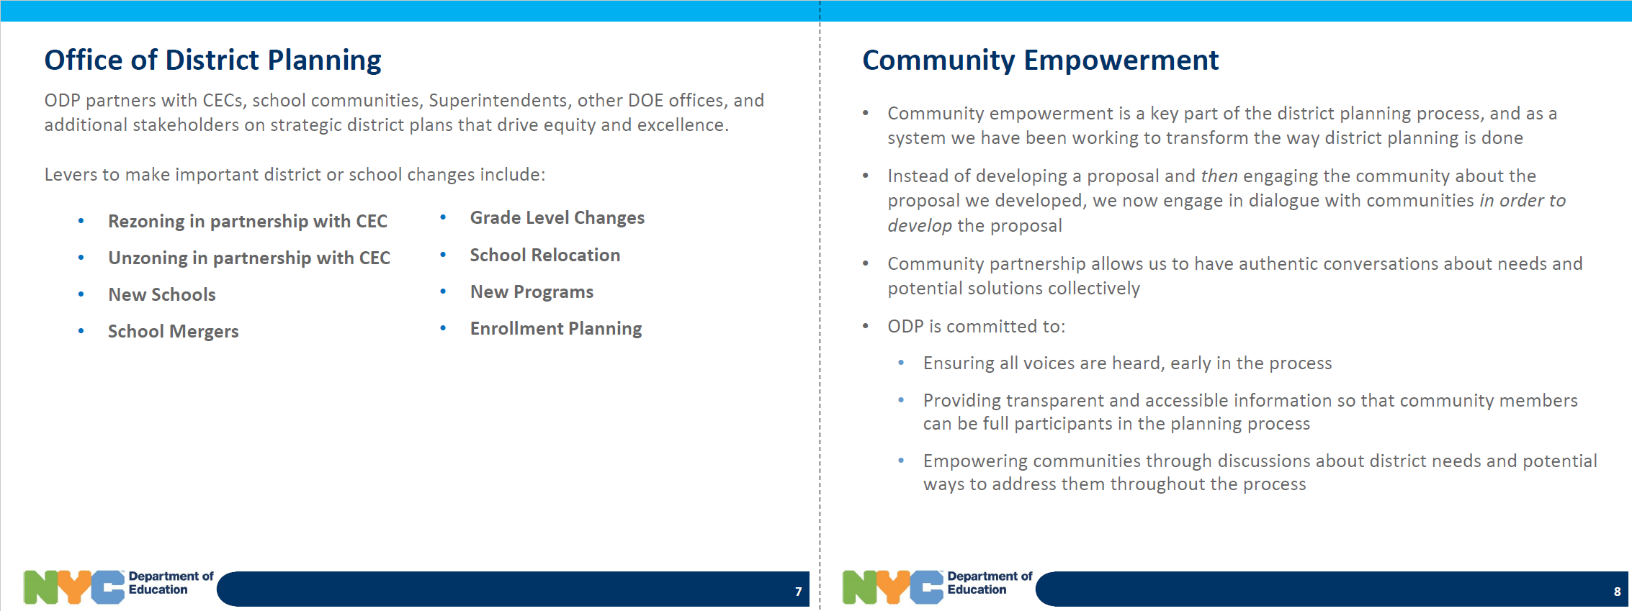

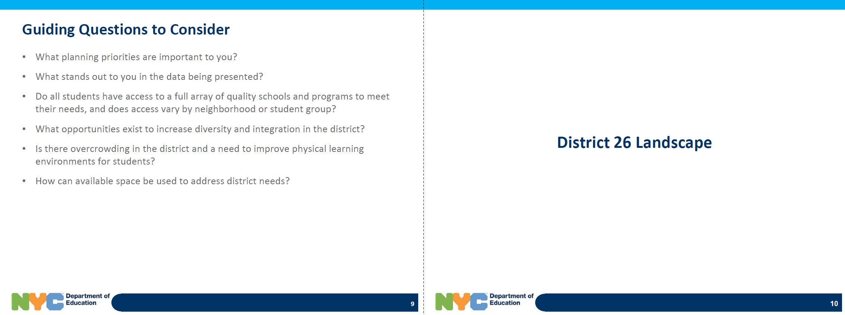

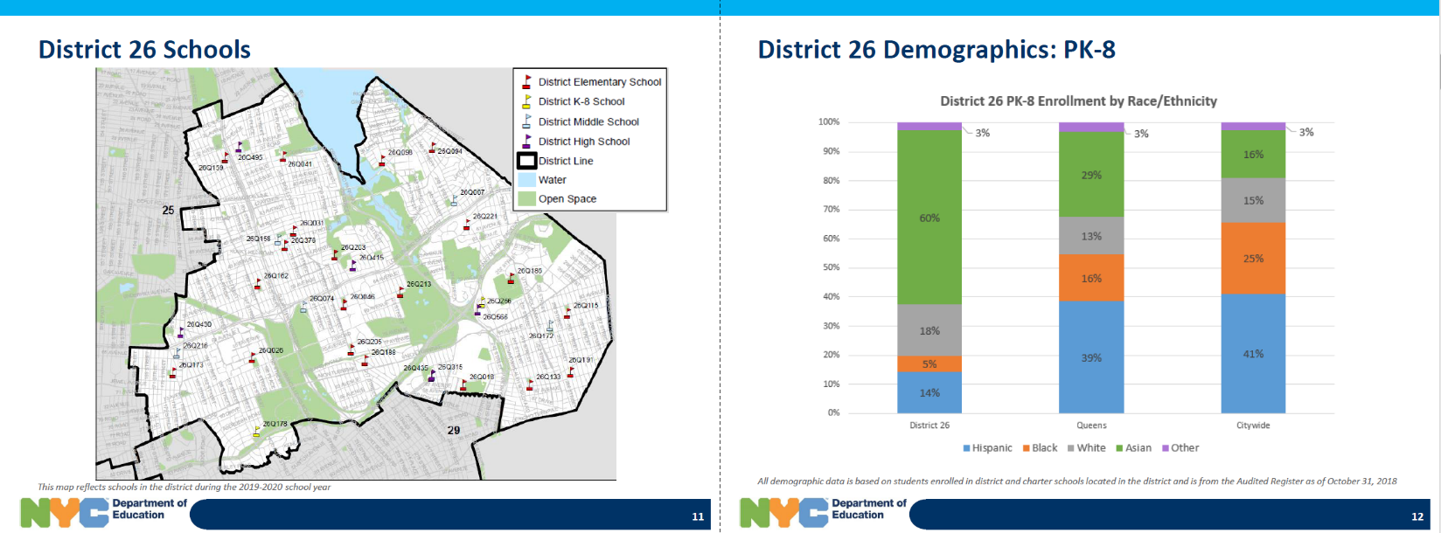

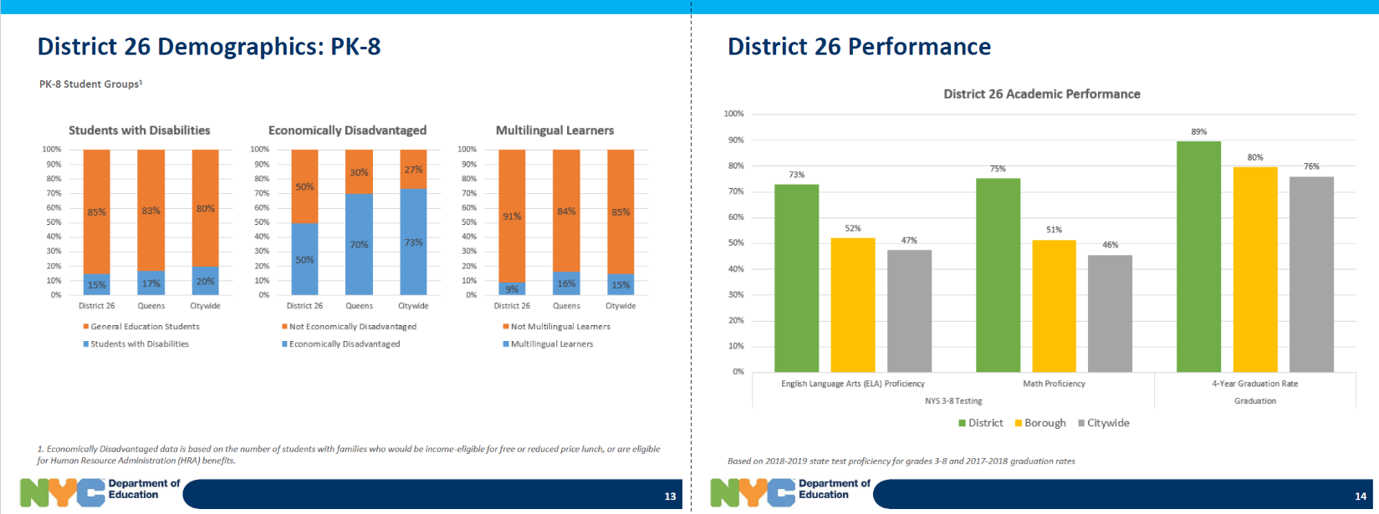

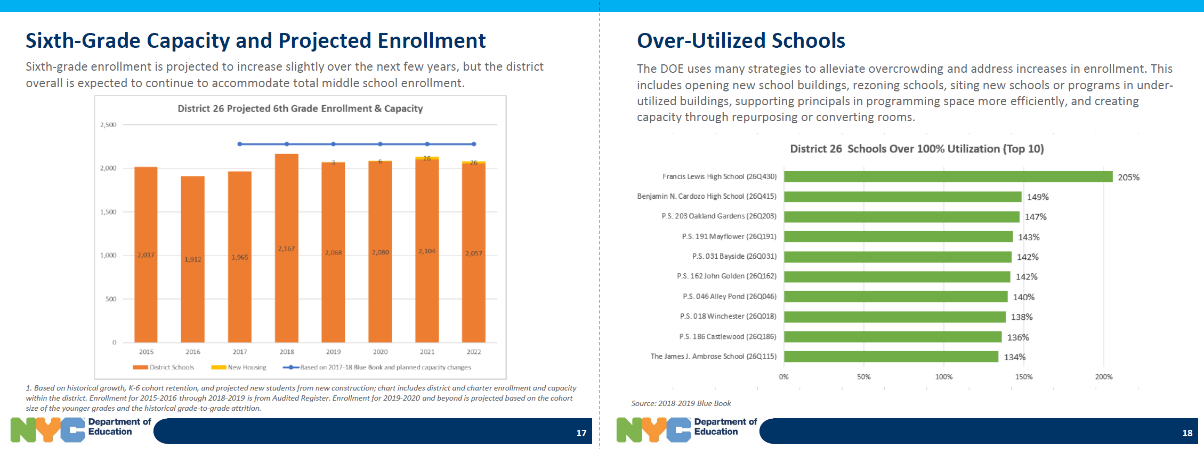

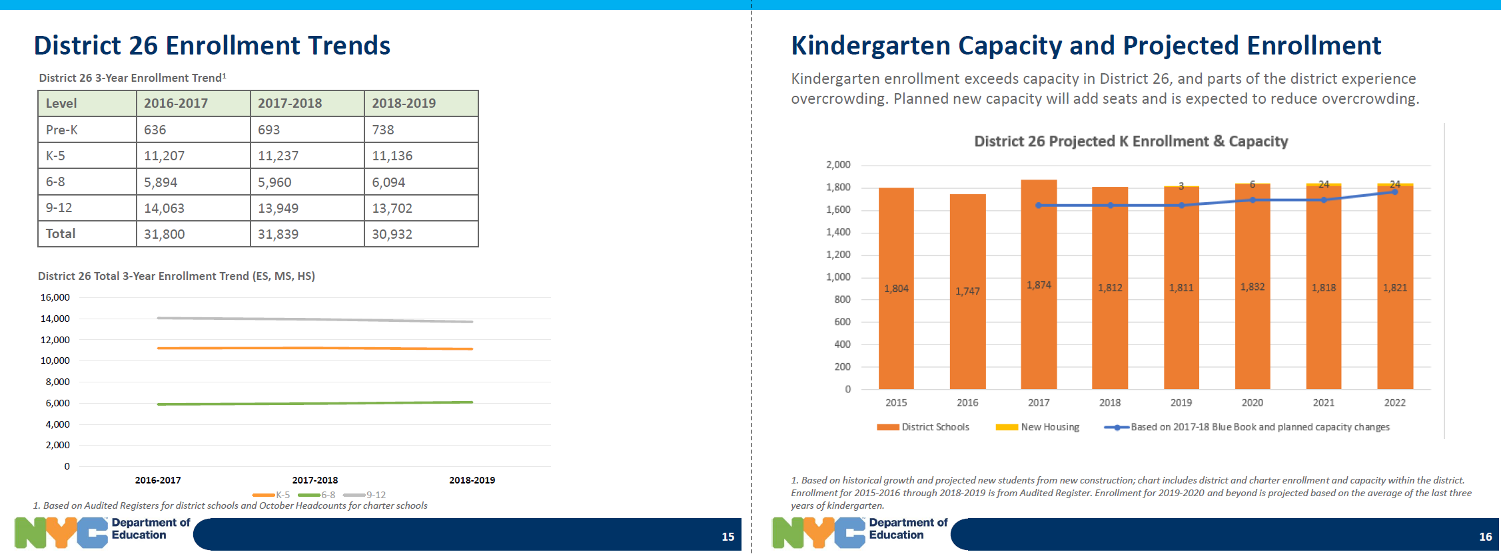

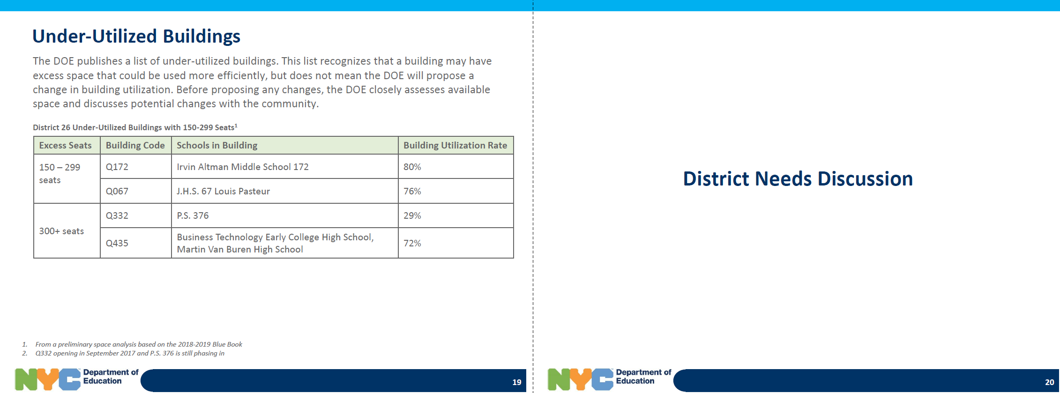

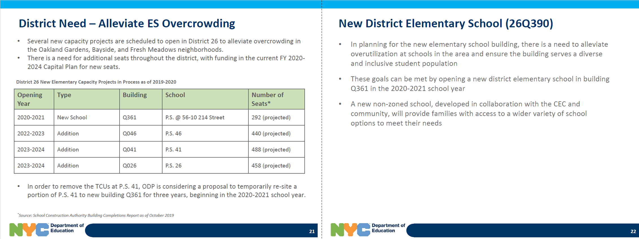

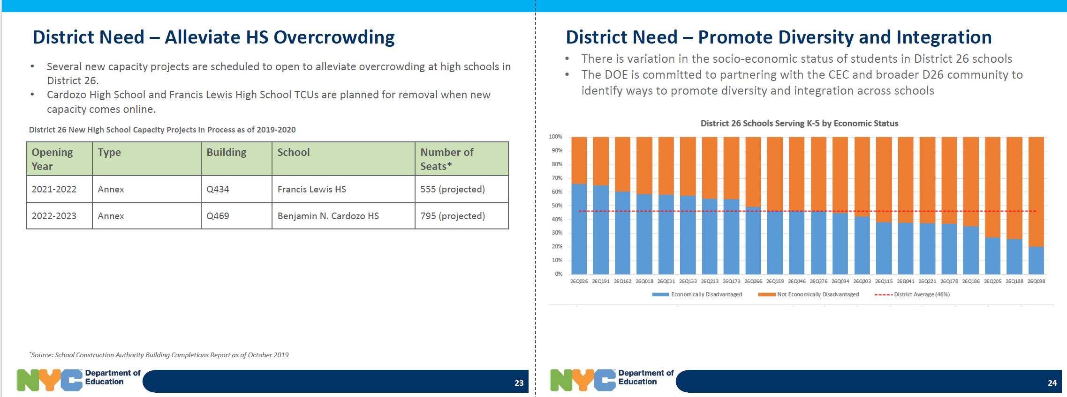

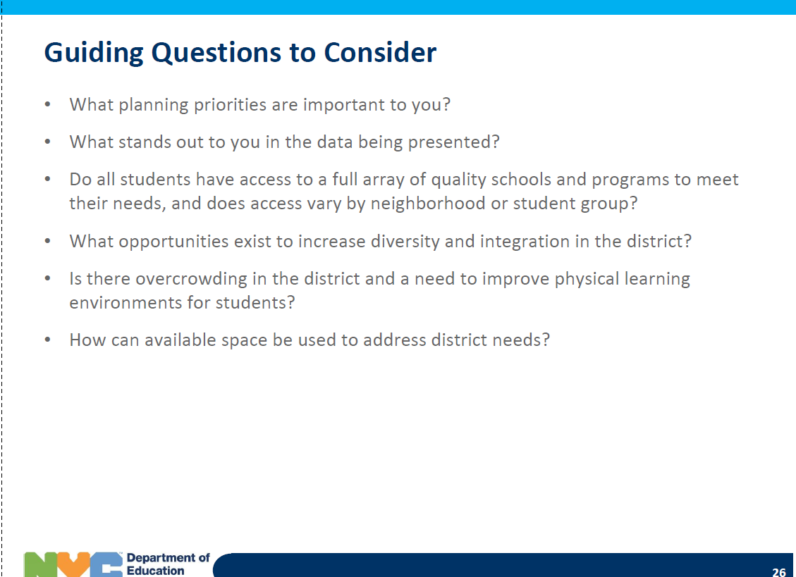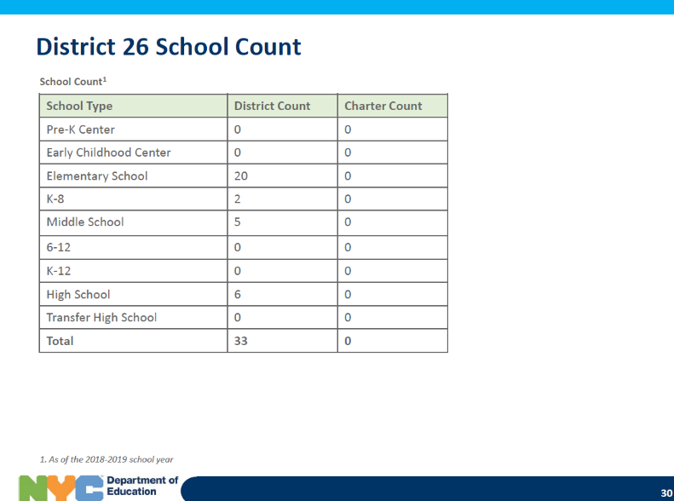

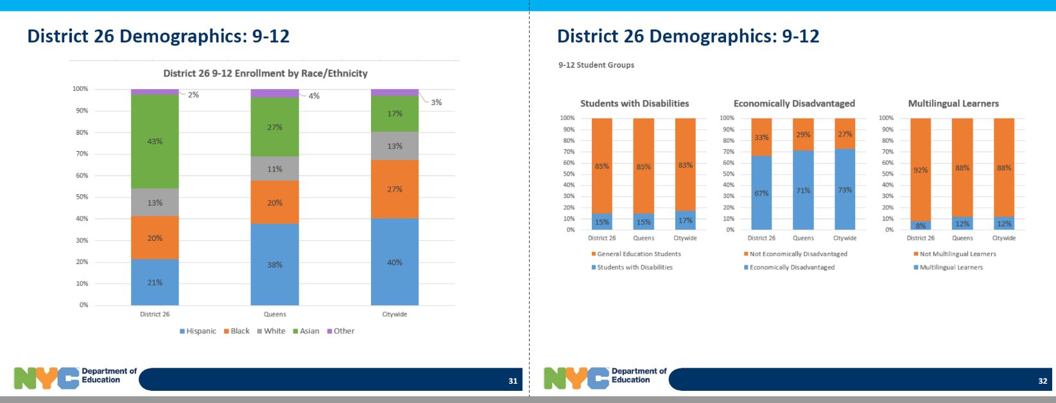  
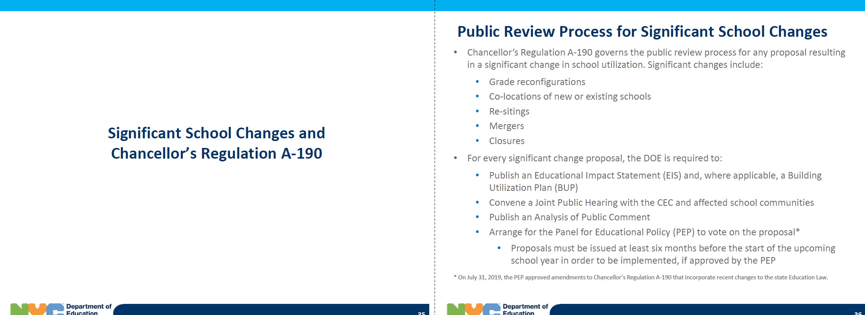

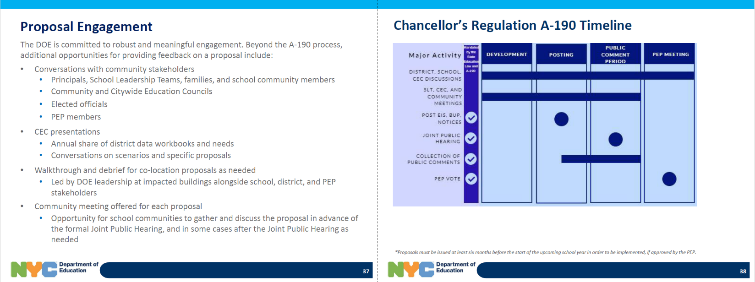

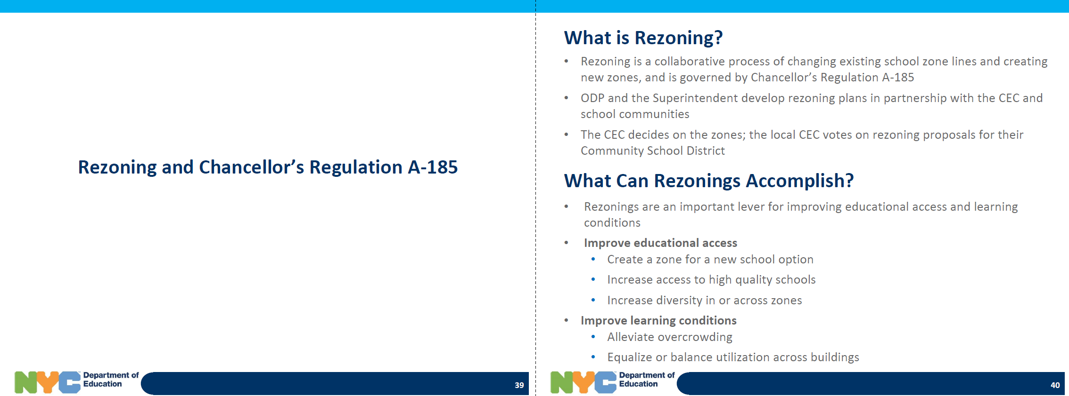

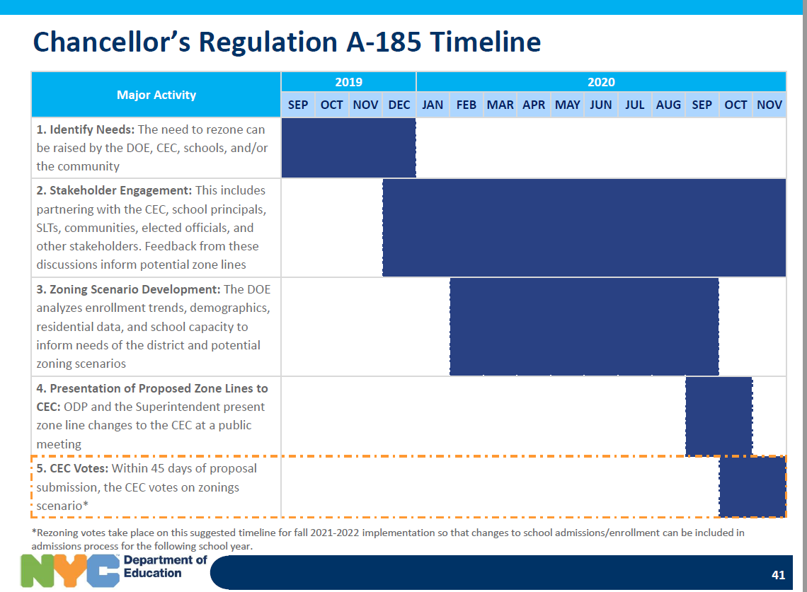

Budget Report

** Community District Education Council 26**

**New York City Department of Education**

***Address:* 61-15 Oceania Street, Bayside, NY 11364 *Phone:*  (718) 631-6927 *Fax:* (718) 631-1347 *E-mail:* CEC26@schools.nyc.gov.**

**November CEC26 Budget Report**

**Opening balance is: $17,328.36**

**Total Expense: 0**

**Closing balance is: $17,328.36**

**Detail:**

We received additional $5000 from the Chancellor-

We are adding $3,000 for vendor payments for Workshop

We are adding $1,500 for supplies

We are adding $500 for vendor payment for Website Services.

|  |  |  |  |  |  |  |
| --- | --- | --- | --- | --- | --- | --- |
|  | **Allocated** | **July** | **Aug** | **Sept** | **Total & Committed** | **Balance** |
| **Non Contractual Services(Copier) Object Code 433** | **$1,548.00** |  |  | $1,548.00 | **$1,548.00** | **$0.00** |
| **Member Reimbursement Object Code 496** | **$2,000.00** | $75.64 |  | $50.00 | **$125.64** | **$1,874.36** |
| **P-Card/Office Supplies** | **$5,000.00** |  |  |  | **$0.00** | **$5,000.00** |
| **Supplies General (Workshops) Object Code 198** | **$3,000.00** |  |  |  | **$0.00** | **$3,000.00** |
| **Workshop & Transportation of Staff** | **$5,382.00** | $404.33 |  |  | **$404.33** | **$4,977.67** |
| **Website** | **$170.00** |  |  |  |  | **$170.00** |
| **Vendor Payment for Workshops** | **$2,500.00** | $200.00 |  |  | **$200.00** | **$2,300.00** |
| **Supplies Water** | **$370.00** |  |  | $369.91 | **$369.91** | **$370.00** |
| **Water rental** | **$30.00** |  |  | $23.76 | **$23.76** | **$6.24** |
| **Total** | **$20,000.00** | **$679.97** | **$0.00** | **$1,991.67** |  |  |
| **Total Spent** | **$2,671.64** |  |  |  | **$2,671.64** |  |
| **Balance in Budget** | **$17,328.36** |  |  |  |  |  |