
Community District Education Council 26
New York City Department of Education

Address: 61-15 Oceania Street, Bayside, NY 11364 Phone: (718) 631-6927 Fax: (718) 631-1347 E-mail: CEC26@schools.nyc.gov

 | Albert Suhu (interim)  President of the Council |  | Vacant  First Vice-President | Cassandra Louie  Second Vice President | Vacant  Recording Secretary | Dennis Chan  Treasurer
Council Members:  Adriana Aviles  Norman Cohn  Jennifer Catherall |  | Todd Friedman  Sulinda Hong  Dilip Nath |  | Student Member:  Mollie Grodsky | District 26 Community Superintendent:  Danielle Giunta
Resolution to Amend Bill S9460/A10498 “Class Size Reduction”
October 13, 2022

WHEREAS, the New York State legislature passed Bill S9460/A10498 “Class Size Reduction” on Jun 2, 2022; and

WHEREAS, Governor Hochul signed the bill into law on Sep 8, 2022; and

WHEREAS, Bill S9460 is intended to amend Section 211-D “Contract for Excellence” Education (EDN) Chapter 16, Title 1, Article 5, Part 1, with the statute enumerating allowable programs, of which (i) class size reduction is only one of six programs, that includes (ii) programs that increase student time on task, including but not limited to, academic after-school programs, (iii) teacher and principal quality initiatives, (iv) middle school and high school restructuring, (v) expansion or replication of effective model programs for students with limited English proficiency, and (vi) full-day kindergarten or prekindergarten.”; and

WHEREAS, the preface (Summary of Provisions) to S9460 states, “require New York City to develop a class size
reduction plan to reduce class sizes over the next five years, with input from parents and stakeholders.”; and

WHEREAS, the amendment to subparagraph (ii) of paragraph (b) of subdivision 2 of section 211-d of the Education Law S9460 states, “ include a plan, which shall be developed in collaboration with the collective bargaining units representing teachers and the principals and signed off on by the chancellor and the presidents of each bargaining unit, to reduce [average] actual class sizes”; and

WHEREAS, the development of the citywide plan to reduce class sizes, as stated in the bill, clearly does not include “input from parents and stakeholders” such as Community Education Councils, Presidents’ Councils, District Superintendents, Citywide Council on High Schools, etc. but directly involves the collective bargaining units; and

WHEREAS, current statute in subparagraph (ii) of paragraph (b) of subdivision 2 of section 211-d of the Education Law, the sentence, “Such plan shall include class size reduction for low performing and overcrowded schools”, is replaced with “The class size reduction plan shall prioritize schools serving populations with higher poverty levels.” in S9460; and

WHEREAS, prioritizing schools serving populations with higher poverty levels that already receive academic intervention services funded through Title I unfairly penalizes schools that are not necessarily serving populations with higher poverty levels but are nevertheless severely overcrowded and enroll large numbers of children living below poverty levels; and

WHEREAS, two of the most overcrowded districts in the city, Districts 25 and 26, lack any space in their schools to create new classrooms for class size reduction (refer to Exhibit A); and

WHEREAS, increasing capacity through the construction of new schools or additions/annexes to existing schools require many years of planning and construction before new classroom space is available for class size reduction; and

WHEREAS, class size reduction could conceivably reduce current levels of enrollment in specialized programs, such as STEM, computer science, Gifted and Talented, screened programs, regents-level classes, Advanced Placement, etc.; and
THEREFORE, BE IT RESOLVED, Community Education Council 26 (CEC26) urges Governor Hochul to require “chapter amendments” to Bill S9460/A10498 to include provisions for:

- Funding of other allowable programs under the Contract for Excellence, such as Time on task, Teacher and principal quality initiatives, Middle school and high school restructuring, Full-day pre-Kindergarten and Model programs for English Language Learners are not reduced from current levels to fund the mandated reductions in class size
- Active and meaningful participation with District Superintendents, Community Education Councils, Presidents’ Councils, Citywide Council on High Schools and other parent stakeholder groups in developing the plan to reduce class sizes, such that each community school district annually submits to the Department of Education an updated and prioritized list of schools to be targeted for class size reduction
- The Department of Education to include schools from each of the 32 community school districts and from a prioritized list of high schools provided by the Citywide Council on High Schools to be included in the class size reduction plan, such that each school district be treated equal in priority for planning and receiving funding for class size reduction programs
- Severely overcrowded districts, regardless of academic performance levels or poverty levels, are immediately allocated funds in the capital budget for building new capacity
- Preservation (or expansion) of the current numbers of seats in existing specialized programs, such as ELL, dual-language, STEM, computer science, CTE, Gifted and Talented, screened programs, regents-level classes, Advanced Placement, etc. upon implementation of class size reduction programs

Community Education Council District 26 approved this resolution on October 13, 2022, at the monthly meeting
by unanimous vote. Members Present: Yes: Albert Suhu, Dennis Chan, Sulinda Hong, Jennifer
Catherall, Dilip Nath and Todd Friedman.

Exhibit A – Utilization Rates of Community School Districts in 2019

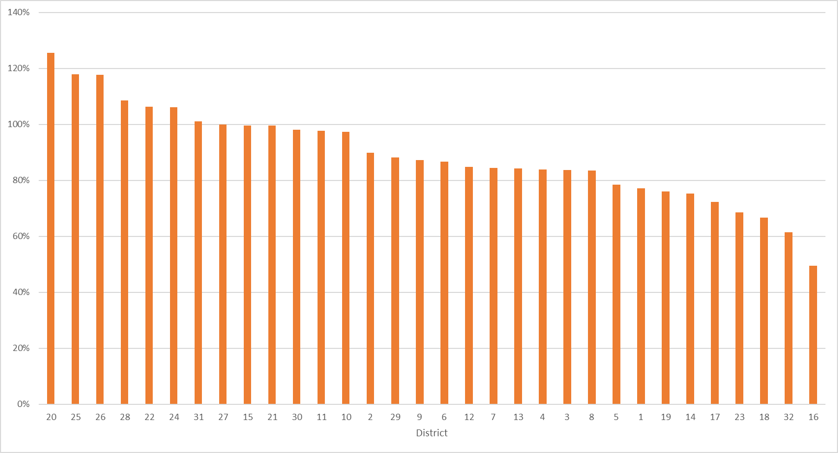

https://www.nytimes.com/2022/06/03/nyregion/nyc-schools-class-sizes.html
https://gothamist.com/news/gov-kathy-hochul-signs-nyc-class-size-cap-with-one-year-delay
https://www.nysenate.gov/legislation/laws/EDN/211-D
https://www.nysenate.gov/legislation/bills/2021/s9460
https://legislation.nysenate.gov/pdf/bills/2021/s9460

